

CCTV Code Of Practice

|  |  |
| --- | --- |
| **Document Title** | CCTV Code of Practice |
| **Document Owner** | Operations Manager |
| **Author** | Operations Manager |
| **Document Version** | 1 |
| **Approved by** | General Manager/The Beatles Story Board |
| **Created Date** | July 2024 |
| **Reviewed** | May 2025 |
| **Next Review Date** | May 2026 |

# This document is confidential and the property of The Beatles Story LTD.

**It may not be reproduced or used for any other purpose than that for which it is supplied without the written permission of The Beatles Story Ltd.**

**Contents**

Introduction Page 3

Code Of Practice Page 4

Responsibilities Of the Operations of The System Page 5 Statement of Purpose Page 5

Privacy & Data Protection Page 7

Accountability & Public Information Page 9, Assessment of The System & Codes of Practice Page 9, Employment Matters Page 10

Control And Operation of Cameras Page 13

Access Arrangements Page 14

Management Of Records Material Page 15

Digital Image Recording Procedures Page 15

# Introduction and Objectives

Introduction

The Beatles Story Ltd owns and operates a Closed-Circuit Television (CCTV) System throughout its premises, Albert Dock and Pier Head. Images are monitored and recorded at both sites.

This document, along with individual system Codes of Practice, is designed to give clear guidelines on The Beatles Story’s use of CCTV, protect the organisation and its CCTV operators from allegations of system misuse, and protect staff and the public from any abuse of the CCTV system.

This policy covers using CCTV equipment and gathering, storing, using, and disposing of visual data. It applies to all staff employed by The Beatles Story and should be the standard expected from any external agencies or people who operate CCTV systems on its behalf.

Definitions

|  |  |
| --- | --- |
| Controller: | **The Beatles Story Ltd** |
| Owner: | **The Beatles Story Ltd** |
| System Administration Manager: | Operations Manager (Day-to-Day Responsibilities) |
| System Ownership: | **The Beatles Story Ltd** |
| Data Protection Policy & GDPR Policy: | **LCRCA** |
| Commissions Office Registration: | **The Beatles Story Ltd** |

Objectives of the System

The objectives of the CCTV system are to reduce crime and the fear of crime by helping to provide a safer environment for those who visit and work within The Beatles Story premises, or assist staff in carrying out their duties.

The system will provide the Police and partner agencies with assistance to detect, deter and prevent crime. It will:

* help identify, apprehend, and prosecute offenders.
* provide the Police with evidence to enable criminal and civil proceedings to be brought to the courts.
* and help to maintain public order.

In addition, the system will enable crime detection and prevention, and The Beatles Story will effectively manage the public and contractors.

Images captured by the CCTV system may also be accessed during internal disciplinary investigations, subject to the framework set out in the Employment Matters section of this Code.

The system will continuously be operated with due regard for individuals' privacy. It will not invade any individual's privacy in residential, business, or other private premises, buildings, or land.

The system will not be used to harass any person or group who is lawfully going about their business.

Any user who violates an individual's privacy in breach of this Code of Practice will be subject to The Beatles Story LTD’s disciplinary procedures.

Legislation

In addition to the Beatles Story policies, procedures, guidelines, and Codes of Practice issued by the Information Commissioner and Surveillance Commissioner, CCTV and its operation are subject to legislation under:

* The Data Protection Act 1998 (DPA 1998)
* The (UK) General Data Protection Regulation (GDPR)
* The Data Protection Act 2018 (DPA 2018)
* The Human Rights Act 1998 (HRA)
* The Freedom of Information Act 2000 (FOIA)
* The Protection of Freedoms Act 2012

# Code of Practice

The key objectives of the system are to:

* provide public reassurance and deter crime.
* detect, prevent, or reduce the incidence of all crime.
* improve general security in the area, both in terms of personal safety and the security management of buildings and premises.
* reduce graffiti, vandalism, and other criminal damage.
* reduce the disorder and minor crime level in and around the premises.
* Improve communication between staff, contractors, and Police patrols in the areas covered and assist in policing the area.
* assist the Police with specific operations aimed at catching criminals or gathering intelligence in the event of acts of terrorism or civil emergencies.
* monitor contractors to provide information on their location for security and protection.
* monitor contractors’ attendance and adherence to the conditions of the contract.
* protect the Beatles Story from spurious claims of negligence.
* assist with surveying the premises to ensure the property is orderly.
* allow The Beatles Story to claim the cost of damage to its premises by others.
* allow The Beatles Story to investigate incidents involving staff and public members in and around its premises.

Any member of the General Public who approaches the Beatles Story requesting to view the content of any CCTV images regarding any incident will be advised to contact the Beatles Story via email ([enquires@beatlesstory.com](mailto:enquires@beatlesstory.com)). The General Manager will ascertain the

validity of the request. Where a member of the public asks explicitly to see CCTV images of themselves, they should be advised of the subject access provisions under the DPA or the GDPR.

Emergency Services or Law Enforcement Agencies' requests for CCTV images must be made on the agreed standard form (Appendix 5) and submitted to The Beatles Story via email ([enquires@beatlesstory.com](mailto:enquires@beatlesstory.com)). Upon collection of the USB, the requester will also sign a Data Release Form and accept responsibility as part of their obligations under the DPA 2018 or the GDPR for any image(s) released into their care.

All internal requests for access to CCTV images for business reasons, whether live or recorded, must be made via the CCTV request form on the online system. Only footage that must be downloaded for future viewings will be stored on the company's private CCTV drive and not shared with individuals.

All images provided to external third parties (other than those detailed above, Emergency Services or Law Enforcement Agencies) must be accompanied by a covering letter describing the conditions under which the images are disclosed (i.e., for use in legal proceedings, as a subject access request, etc.).

Employment Matters addresses the procedure for internal requests for HR purposes, including employees' responsibilities when handling the images.

All CCTV images provided by The Beatles Story shall always remain the property of The Beatles Story, and at no time is the Copyright transferred to the recipient.

No CCTV shall intentionally overlook and view private premises without prior consent from the occupiers.

The General Manager will seek advice on all requests from the organisation's Data Protection Officer, whose contact details are included in the company's Data Protection Policy.

# Responsibility of the Operators of the System

The Operators of the system shall have prime responsibility for:

* compliance with the purpose and objectives of the system.
* operation and security of the system.
* the protection of the interests of the public and the individual as far as is practical.
* compliance with this Code of Practice.
* compliance with all legislation regarding the use of the system.

# Statement of Purpose

Purpose

This document states how the Beatles Story intends to use the CCTV System to meet the objectives and principles outlined in the Code of Practice.

General Principles of Operation

The CCTV System will be operated fairly, within the law, and only for the purposes for which it was established, identified within this code or subsequently agreed upon by this code.

The CCTV System will be operated with due regard to the general right to respect for an individual’s private and family life and their home, as set out in Article 8 of the HRA.

Ensure the security and integrity of operational procedures to safeguard the public interest in the operation of the CCTV system.

Throughout this Code of Practice, as far as reasonably possible, it is intended to balance the CCTV System's objectives with the need to safeguard individual rights. Every effort has been made to indicate that a formal structure has been put in place, including a complaints procedure, by which it can be identified that the system is not only accountable but also seen to be accountable.

Any organisation, individual, or authority's participation in the system assumes that all such participants agree to comply fully with this code and to be accountable under the Code of Practice.

Monitoring and Recording Facilities

The CCTV System at The Beatles Story, Albert Dock, uses several digital network video recorders. These devices record all camera feeds from The Beatles Story system according to the network design and architecture.

Access to recorded data is recorded on the system's log, and user credentials are logged as part of this data recording. The purpose of this is to audit which operator has bookmarked specific footage.

The footage recording will be heavily restricted to a few Officers (currently the Operations Team, Security/GSO team, and the General Manager). Viewing live footage will only be allowed by appropriate officers following appropriate justification and duly recorded on the CCTV request form on the company’s online platform.

The General Manager will approve all requests. The Assistant Director of Customer Service Delivery will verbally approve the General Manager's bookmarking of specific footage and follow up with email authorisation.

The Operations Manager will administer monthly audits, and all data logs will be shared with the General Manager. Access log records will be checked against the CCTV request form. Access logs not authorised via the CCTV request form on the company’s online platform will be highlighted and investigated.

Training

Staff will be suitably trained, and authorised visitors will only have access to the monitoring facility with an authorised member of staff always present.

Processing and Handling Recorded Material

No recorded material, whether digitally, in analogue format, or as a hard copy of video print, will be released unless under this Code of Practice and relevant legislation.

Changes to the Code

This Code of Practice will be regularly reviewed to ensure that it reflects best practice and responds to legislative changes. Any significant changes to the Code of Practice will occur only after consultation with and upon agreement with The Beatles Storyboard. Minor changes will be made by the Operations Manager and authorised by the General Manager on behalf of The Beatles Story.

A significant change will significantly impact the Code of Practice or the operation of the CCTV System. A minor change, for example, may be required for clarification or arise due to technical changes to the CCTV system and will not have any significant implications.

Any change to the Code that may impact the way the Code affects The Beatles Story staff regarding potential disciplinary investigations or procedures will be the subject of an agreement with the trade unions before its implementation.

Breaches of the Code of Practice and Security

Prime responsibility for the Code of Practice and security surrounding the system rests with The Beatles Story LTD.

This responsibility includes ensuring that breaches are investigated, reported and remedied under the Data Protection Policy.

Responsibility for security on a day-to-day basis rest with the Operations Manager.

Significant breaches of the Code of Practice will be reported to the company's Data Protection Officer by the General Manager and investigated by the company's Data Protection Officer. They shall be responsible for making recommendations to remedy any proven significant breach.

The Data Protection Officer will report breaches to the Information Commissioner when appropriate. The matter will be referred to the relevant Law Enforcement Agencies if a criminal offence is disclosed.

# Privacy and Data Protection

Public Concern

Although most of the public may have become accustomed to “being watched,” those who express concern do so mainly over processing the information (or data), i.e., what happens to the obtained material.

All personal data obtained by the system shall be processed fairly and lawfully and only to achieve the system's stated objectives. In processing personal data, a person’s right to respect their private and family life and home will be respected per Article 8 of the HRA.

The processing, storage, and security of the data will strictly follow the requirements of the DPA 2018, the GDPR, and additional locally agreed-upon procedures.

Data Protection Legislation

On 25 May 2018, the DPA 1998 was replaced by the GDPR, which became the UK’s data protection legislation. Upon withdrawal from the EU, the GDPR's contents were adopted as the (UK) General Data Protection Regulation.

The operation of the System has been notified to the Information Commissioner’s Office following the DPA requirements. The Beatles Story LTD registration number is ZB689979.

The Beatles Story is the system's “controller,” and the Security Team will assume day-to-day responsibility for the data.

All personal data will be processed by the principles contained in Article 5 of the GDPR, which state that personal data will be:

* processed fairly and lawfully.
* collected for specified, explicit and legitimate purposes and not further processed in a manner that is incompatible with those purposes.
* adequate, relevant, and limited to what is necessary for the purposes they are processed.
* accurate and, where necessary, up to date.
* kept in a form which permits identification of data subjects for no longer than is necessary for the purposes for which the personal data are processed.
* processed in a manner that ensures appropriate security of the personal data, including protection against unauthorised or unlawful processing and accidental loss, destruction or damage, using appropriate technical or organisational measures.

Requests for Information (Subject Access)

Any request from an individual to disclose their data, which they believe is recorded by the System, should be directed in the first instance to The Beatles Story email ([enquires@beatlesstory.com](mailto:enquires@beatlesstory.com)). Without exception,

If any footage is held, the General Manager will inform the Senior Information Management Officer, who will respond to the requester.

Every request shall be treated according to the principles of the DPA 2018, the GDPR, and the FOIA.

If the request cannot be complied with without identifying another individual, permission from that individual must be obtained unless it is reasonable in all circumstances to comply with the request without that individual's consent.

Any person making a request must be able to prove their identity and provide satisfactory proof and

sufficient information to enable the data to be located.

# Accountability and Public Information

The Public

The Code of Practice restricts access to The Beatles Story CCTV for security reasons.

A member of the public wishing to register a complaint about the System may contact The Beatles Story Ltd.

The Beatles Story’s complaints process will handle all complaints which will be sent to the General Manager for review.

Any performance issues identified will be considered under the organisation's Disciplinary Procedures, which all employees, including CCTV personnel, are subject to.

Concerns about The Beatles Story’s use of personal information can be directed to [DPO@liverpoolcityregion-ca.gov.uk](mailto:DPO@liverpoolcityregion-ca.gov.uk).

Public Information

A copy of this CCTV Code of Practice shall be published on The Beatles Story’s website. Signs

Signs (see Appendix 2) will be placed in the locality of the cameras and at the main entrance points to the relevant areas. The signs will indicate:

* the presence of CCTV monitoring.
* the ‘Ownership’ of the System.
* contact telephone number 0151 709 1963 Fair Processing Notice

The GDPR requires additional information to be communicated to the public when their data is collected.

The entire Fair Processing Notice for The Beatles Story CCTV system is in Appendix 4.

# Assessment of the System and Codes of Practice

Evaluation

The System will periodically be evaluated to establish whether its purposes are being complied with and whether objectives are being achieved in addition to compliance. The Operations Manager will review the CCTV plan annually for all areas, and any changes or additions will be forwarded to the General Manager for review. The General Manager will raise any concerns with the Senior Information Management Officer.

Monitoring

The Operations Manager and Guest Service Officers will accept daily responsibility for monitoring and operating the System and implementing this Code of Practice.

Audit

Monthly audits of the system's operation will include examination of The Beatles Story’s records, media histories, the content of recorded materials, and site visits by the Operations Manager.

# Employment Matters

Monitoring of Employees Using CCTV

The Beatles Story is a responsible and reasonable employer and, as such, will ensure that monitoring using CCTV will be sensible and proportionate. There is a legitimate

expectation that employees’ personal lives will remain private and that their everyday competence within the job role will be assumed. The employer will trust the employees as far as is reasonably practical.

CCTV will only be used to monitor employee activity and investigate potential misconduct or health and safety procedures breaches within the spirit of this understanding and this Code of Practice.

Such monitoring is allowed under GDPR as it represents the processing of personal data as part of a contract between The Beatles Story and the employee. However, it is recognised that failing to follow the agreed procedures as detailed within this Code of Practice may result in any evidence collected being rendered inadmissible for disciplinary purposes.

Any breach of this procedure will lead to an investigation and could result in disciplinary action. Managers should also be aware that violating the data protection legislation related to accessing CCTV footage may lead to prosecution of the individual employee of The Beatles Story and the organisation as the employer.

When deciding whether or not to request and subsequently view CCTV footage, consideration will be given as to whether it is proportionate and reasonable to view the footage when balanced with the interests, rights and freedoms of employees.

Those undertaking any investigation and considering the use of CCTV footage should satisfy themselves that they have appropriately answered the following questions;

* Am I mindful of the Beatles Story’s Policies, Guidelines, Code of Practice, and relevant legislation and regulations?
* Is this a proportionate action?
* Can this investigation be reasonably and fairly completed without CCTV footage?
* What is the precise purpose of observing the CCTV footage?
* Have I obtained approval from the general manager to use CCTV footage before viewing it?
* Have I approached the CCTV System Administrators or one of the designated

controllers correctly?

* Have I notified the employee of my intention to view the CCTV footage?
* Have I notified the HRD of my request to access CCTV footage?
* Has the CCTV Impact Assessment been fully completed and approved? (See Paragraph 8.4)
* Is the request specific? Footage will not be provided for different dates or timelines without completing the required forms.

CCTV Operators

Data controllers or system Administrators will not be permitted to use the CCTV system until they have received suitable training and are familiar with this Code of Practice.

Every person involved in the management and operation of the System will be personally issued a copy of the Code of Practice. They must sign confirming that they fully understand their obligations to adhere to this Code of Practice (issued electronically via the company's E-Learning platform).

Breach of the Code of Practice

Any breach of this Code of Practice by either those requesting or giving access to CCTV footage or any breach of confidentiality will be dealt with following the organisation’s disciplinary procedure.

Use of CCTV in potential disciplinary proceedings

CCTV footage captured by the system may be used to investigate disciplinary matters following the Disciplinary Policy or potential health and safety breaches.

Access to CCTV will only be granted when it is a proportionate and necessary means of detecting the conduct in question. This will be decided using a CCTV Impact Assessment (Appendix 5).

The procedure to be followed to access CCTV footage is:

1. The Manager identifies the specific locations, time, behaviour, and staff to be observed via the CCTV system.
2. The Manager completes the Impact Assessment form located in Appendix 5, emails this to the General Manager, and copies in [humanresources@beatlesstory.com](mailto:humanresources@beatlesstory.com)
3. The Assistant Director of Customer Service Delivery must approve any request made by the General Manager. Authorising CCTV footage to be viewed does not preclude the General Manager/ Assistant Director of Customer Service Delivery from involvement in any subsequent disciplinary proceedings.
4. The HRD (or nominated deputy) considers the submitted Impact Assessment form. A copy of the form is saved and logged in the employee's People HR documents, with only Administrator access to the system.
5. The HRD (or nominated deputy) returns the Impact Assessment form to the

The manager is confirming the outcome of the impact assessment.

1. Once the Impact Assessment has been returned to the Manager with approval, they are to complete the CCTV request form on the online system.

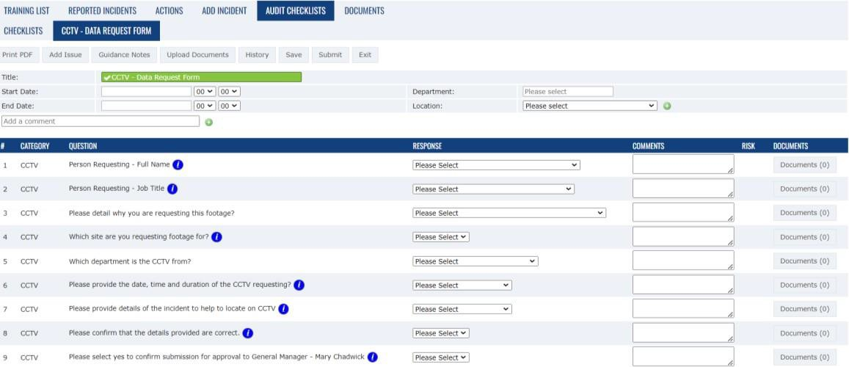

1. The manager informs the employee that CCTV footage will be viewed as part of the investigation to establish the facts. This will generally take the form of an investigation meeting, where a representative of the HRD will accompany the manager. After the meeting, the employee will be asked to digitally sign the CCTV Impact Assessment form released on People HR to confirm that they have been informed that CCTV will be viewed.
2. The manager emails the data controller, quoting the original CCTV reference number. To request that the footage be copied to a USB, the manager must ensure that the footage is viewed in a location that ensures confidentiality and is only available to the investigating officer and HRD representative. Where no further action is taken, the footage will be destroyed by returning the USB to General Manager for confidential and secure shredding witnessed by a representative of the HRD; where the investigation results in a disciplinary warning, the footage will be retained, along with other disciplinary records, for the duration of any disciplinary tariff awarded, or for six years following termination of employment, after which time the footage will be destroyed;
3. If something is viewed that is to be investigated further, the employee must be allowed to view the footage.

Supplementary Footage or Incidents

The manager must only view the CCTV footage of the actual alleged incident within the date and timeframe as detailed within the approved CCTV Impact Assessment. Viewing additional footage or “fishing” for further acts of misconduct will be considered a breach of this Code of Practice. The data control officer hosting the visit to CCTV Data Management will refuse any request that falls outside the parameters of the original request.

CCTV must only be viewed to fulfil its original purposes. Suppose the manager views a

different incident from one initially investigated concerning the same employee or another. In that case, they must treat this as a separate incident and follow the procedure detailed in 8.4, from point iii) onwards. This includes situations where the footage was initially viewed for purposes unrelated to employees, e.g., investigating a customer complaint.

# Control and Operation of Cameras

Guiding Principles

Any person operating the cameras will act with the utmost integrity and respect at all times, without exception.

Maintenance of the System

The Operations Manager shall maintain The Beatles Story's CCTV system to ensure compliance with the Information Commissioner’s Code of Practice and that the images recorded continue to be of appropriate evidential quality.

The maintenance programme will provide regular/periodic service checks on the equipment, which will include cleaning all-weather domes or housings, checking the equipment's functioning, and making any minor adjustments to the equipment settings needed to maintain quality.

Maintenance will also include regular, periodic overhauls of all equipment and replacement of equipment reaching the end of its serviceable life. The Operations Manager will provide the General Manager with a maintenance schedule annually and verify that all actions have been completed.

Documents relating to the maintenance of the system must be kept for future checks.

The Operations Manager will immediately inform the General Manager of any severe faults and what actions have been taken to address them.

Daily Checks

GSO will conduct a daily morning check of the CCTV to ensure that all images, including the correct date and time, are showing on the screens.

The one system has 5 DVR/NVR recorders covering Albert Dock and Pier Head sites. Each DVR/NVR is assigned a number 1,2,3,4, Albert Dock and 5 is Pier Head.

The Security/GSO team will log onto the CCTV each morning to carry out daily visual checks.

The checks to be completed on each of the 5 DVR/NVR’s include

* Check the date displayed on the camera (is showing the correct date)
* Check the time displayed on the camera (is showing the correct time)
* Check that each camera is displaying an image clearly.
* CCTV Monitor, Mouse and Keyboard to be wiped clean, computer screen wipes are kept next to the

keyboard/mouse on the shelf for use.

Once the daily check has been completed, the Security/GSO team will complete the digital checklist, detailing the outcome of the checks and highlighting any faults.

These checks are also carried out weekly by the Operations Assistant and monthly by the Operations Manager.

Please see the example of checks below.

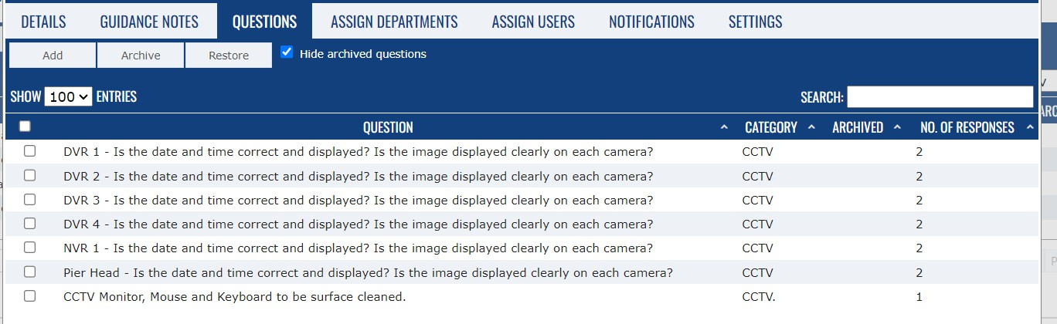

The security/GSO team will contact the Operations Manager immediately and inform them of any faults. The General Manager should be notified in the absence of the Operations Manager.

System amendments must be completed following authorisation from the system owner. Due process includes DPIA and updated CCTV surveillance commissioner self-assessment.

Monthly Checks

GSO will conduct a monthly check on the DVR/NVR hardware recorders at both sites

An approved contractor will train the GSO team to clean the vents on the hardware.

The checks to be completed on each of the 5 DVR/NVR’s include

* Check the recorder vent and clean

Once the monthly check (1st Monday of the month) has been completed, the Security/GSO team will complete the digital checklist, detailing the outcome of the checks and highlighting any faults.

Please see the example of checks below.

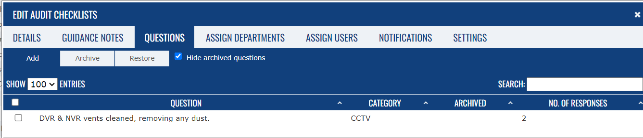

# Access Arrangements and Security of The Beatles Story’s CCTV Equipment Areas.

Access and security arrangements to The Beatles Story shall, as a minimum, comply with the following:

* Access to The Beatles Story’s Comms room, containing the CCTV recording equipment, is strictly controlled by fob access, and only authorised personnel are allowed access. Authorised staff in this room are the GSO (Security Team), Operations Team, General Manager, and Guest Experience Management team, including Team Leaders.
* The CCTV records (DVRs and NVRs) are kept in a locked cabinet. The key is kept in Key Box Safe 4, located in the Security Office, and is signed in and out.
* A detailed record of visitors/contractors to the Comms room containing the CCTV recording equipment will be kept. The Operations Manager will only authorise access to the area. The Security Team will check formal identification before access is given.
* The General Manager will only permit visitors to view the system and will control their access at all times.
* All Data Controllers have access to the system via a Username and Password. This information is private and confidential and must not be shared.

# Management of Recorded Material

Principles

For this Code, ‘recorded material’ means any material recorded by or as the result of technical equipment that forms part of the System but includes explicitly images recorded digitally, on the hard drive, or by way of DVD copying, including prints.

Every recording on a hard drive or DVD obtained by using the system has the potential to contain material that may need to be admitted as evidence at some point during its retention period.

Recorded material will not be copied, sold, released, or used for commercial purposes for entertainment or otherwise made available for any use incompatible with this Code of Practice.

# Digital Image Recording Procedures

Adhering to the agreed management and operational procedures is not just a formality, but a crucial step. It ensures that the digital recordings produced are of sufficient evidential value and quality to be used as evidence in court.

Time-lapsed digital images are automatically recorded and kept on the recording equipment's hard drive for 30 days, after which they are overwritten.

Operators play a crucial role in ensuring data quality. By downloading each recorded image that shows the correct time and date for evidential purposes, they contribute significantly to the integrity of our operations.

If a request for access to recorded images is made within 30 days, only copies of the images specifically requested can be “bookmarked” and held for 3 months.

When the footage is transferred to a USB for disclosure, a master copy will be retained on the CCTV company drive. For Crown Court or criminal cases, the master copy is retained for seven years due to the legal requirement to retain related information. For all other disclosures, a master copy is retained for one year. The Beatles Story’s business needs have determined this retention.

Once downloaded, footage is stored in a private, secure folder on The Beatles Story network. This ensures that the data is accessible only by authorized personnel, instilling confidence in the security of our system.

Digital Recording & Copying Procedure

On receiving a request to view or store digital recordings of a particular incident, the following process should be followed:

The CCTV digital request form on the company's portal should be checked to ensure all data fields have been filled in and the General Manager has authorised the request. The Assistant Director of Customer Service Delivery will authorise the request for the general manager.

The request will include the following:

* Name of the person requesting the copy.
* the organisation that the person represents.
* incident type, e.g., assault, theft, etc.
* date, time, and location of the incident.
* any additional information applicable.

It is important to stress to the recipient of digital image recordings that the images will always remain the copyright of The Beatles Story LTD. Therefore, no images should be released either wholly or partially to a third party without the written consent of the General Manager. A record of all data released will be kept for two years.

Viewing live or recorded images is not a casual activity. It's a process that should be logged using the CCTV digital request form on the company's portal. This ensures a clear and transparent record of all viewings.

Any supporting documentation and forms should be held digitally on the company's network.

# Appendix 1

**System Owners**

The Beatles Story LTD Unit 41

Britannia Pavilion

The Royal Albert Dock Liverpool

L3 4AD

Tel: 0151 709 1963

Email: [enquiries@beatlesstory.com](mailto:enquiries@beatlesstory.com).

# Responsibilities

The Operations Manager plays a pivotal role in ensuring the provision and maintenance of all equipment forming part of the Beatles Story’s CCTV System. This is done following contractual arrangements that the owners may occasionally enter into, ensuring service availability and compliance.

All appropriate internal stakeholders must maintain close liaison with the System Administration Manager.

Ensure the terms of this Code of Practice uphold the interests of the owners and other organisations.

Agree to any proposed alterations and additions to the System and this Code of Practice.

**Appendix 2**

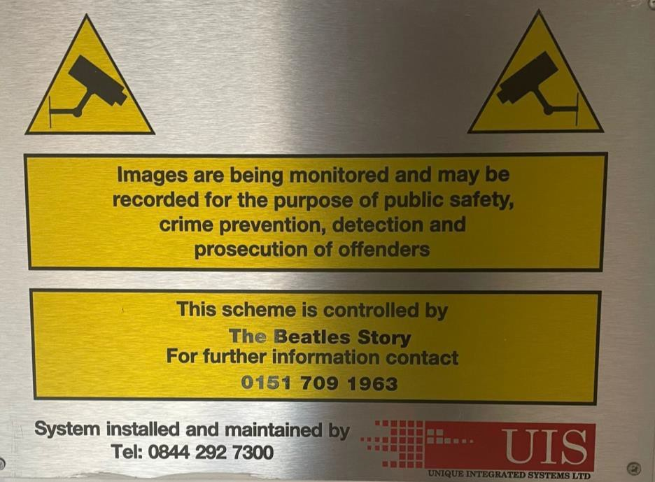

**Appendix 3**

**External CCTV Request Handling Flowchart**

The General Manager will seek advice from the DPO as and when needed.



Verify compliance with DPA/GDPR

TBS Data Controller to record and process.

Data provided to General Manger and issued.

The Beatles Story’s General Manger.

Emergency Services/Policing Agencies

External 3rd Party Insurers, Individual requests

|  |
| --- |
| The Beatle Story’s General Manager. |
|  |
| Verify compliance |
|  |
| Record requests and details in the database |

Download requested data and issue

**Appendix 4**

**CCTV Fair Processing Notice**

**Identity and contact details of the controller and, where applicable, the controller’s representative and the data protection officer**

The Beatles Story is the ‘controller’ for your personal information. This means that we decide the purpose and means of processing the data captured by the CCTV system.

If you have any questions about how your information is being used, you can contact The Beatles Story’s Data Protection Officer at

[DPO@liverpoolcityregion-ca.gov.uk](mailto:DPO@liverpoolcityregion-ca.gov.uk) 0151 330 1679

1 Mann Island, Liverpool, L69 3HN

# Purpose of the processing and the legal basis for the processing

The CCTV system is used by The Beatles Story as outlined in the Code of Practice of this Code. We can do this as part of our legal obligations as an employer.

# Description of the categories of personal data

The categories of information being processed include your image.

The CCTV system does not process any ‘special categories’ personal data.

# Any recipient or category of recipients of the personal data

Your information will be shared with parties such as the police and solicitors, as allowed by the GDPR and the Data Protection Bill, for the purposes of criminal investigation and legal proceedings.

# Details of transfers to third countries and safeguards

Your personal data will not be transferred outside the European Economic Area.

# Retention period or criteria used to determine the retention period.

The CCTV footage will be kept for a period of 30 calendar days from the date of capture. If a request is received within this time to “bookmark” the footage, this will be retained for a period of three months. When the footage is transferred to a USB for disclosure, a master copy will be retained. For Crown Court or criminal cases, the master copy is retained for seven years due to the legal requirement to retain related information. For all other disclosures, a master copy is retained for one year. The Beatles Story’s business needs have determined this retention.

# The existence of each of the data subject’s rights

The GDPR provides you with the following rights when it comes to your personal data:

* The right to be informed how your personal data is being processed.
* Your right to access the personal data we hold about you includes providing copies of the information within one month of a request. We may charge a reasonable fee to provide this information based on our administrative costs of responding (e.g., photocopying, postage, etc.).
* The right to rectification of any incorrect or incomplete data we hold about you.
* The right to erasure, also known as ‘the right to be forgotten’, where,
  + Your information is no longer required for the purpose for which it was collected.
  + You withdraw your consent.
  + You object to Merseytravel processing your information (and there is no overriding legitimate interest for continuing the processing)
  + Merseytravel has breached the GDPR when processing your data.
  + There is a legal obligation to delete the data (such as a court order)
* The right to restrict processing limits what the organisation can do with your information.
* The right to data portability, where any automated processing of your information based on your consent or as part of a contract is made available for reuse.
* The right to object to direct marketing or any processing based on the performance of a task in the public interest/exercise of official authority, or for scientific/historical research and statistics.
* Rights in relation to automated decision-making and profiling, where a decision made by a computer has a legal or significant effect on you.

For further details or to exercise your rights, contact the Data Protection Officer.

[DPO@liverpoolcityregion-ca.gov.uk](mailto:DPO@liverpoolcityregion-ca.gov.uk) 0151 330 1679

1 Mann Island, Liverpool, L69 3HN

# The right to complain to a supervisory authority.

You have the right to complain about the processing of your personal data to the UK’s supervisory authority, the Information Commissioner, who can be reached using the details below:

The Information Commissioner’s Office, Wycliffe House,

Water Lane, Wilmslow, Cheshire SK9 5AF [www.ico.gov.uk](http://www.ico.gov.uk/) 0303 123 1113

# Appendix 5

CCTV Impact Assessment Form: Employment

This form must be completed before requesting access to CCTV footage as part of a potential disciplinary investigation or investigation into health and safety breaches. You are also requested to complete the CCTV access form on the company's E-Learning portal.

Please refer to the CCTV Code of Practice for further guidance and to ensure compliance with the process. You may ask for the footage to be “bookmarked”; however, you must not access the footage at this stage and must specify the location, date, and timeframe to be bookmarked.

You must digitally fill in this form and submit your request to the General Manager via email, copying [humanresources@beatlesstory.com](mailto:humanresources@beatlesstory.com).

The form requesting CCTV will be returned to the manager upon approval from the general manager. The manager will complete the CCTV request form on the online digital system and submit it. Once approved, the request will be issued to one of The Beatles Story LTD's data controllers.

1. What is the purpose of accessing the CCTV footage? Please provide as much detail as possible, including:
   * the name(s) of the employee(s) concerned.
   * details of the actions/activities/incidents to be observed;
   * the alleged misconduct/breach of procedures.
2. Specify the location, date, and timeframe to be viewed.
3. Are there any likely adverse impacts to viewing the CCTV footage?

23

1. Are there any viable alternatives to viewing the CCTV footage? Please explain your rationale for discounting any alternative methods.
2. Has the CCTV footage been viewed previously for a different purpose?

* Yes ☐ No

If yes, please indicate the date that you signed the previous request:

By submitting this form, you agree to understand and abide by the rules for accessing CCTV for employment purposes.

# Additional Footage After Initial Request Approved

If you need to view additional footage, complete and submit a further impact assessment.

Email your request to the General Manager, copying in the HRD [at humanresources@beatlesstory.com](mailto:humanresources@beatlesstory.com)

This email will contain the following –

* Completed by (name):
* Job Title
* Digital Signature:
* Date

# For Completion by the General Manager

Digitally approve the request via email, copying in the manager requesting the footage and the HRD at [humanresources@beatlesstory.com](mailto:humanresources@beatlesstory.com).

This email will contain the following –

* Digital Signature
* Job Title
* Date:

# For completion by the Manager of HRD

**#**

24

**Comments on the application**

Does the impact assessment justify accessing CCTV footage for the date and timeframe indicated?

* + Yes **☐** No

Digitally approve the request via email, copying in the manager requesting the footage and the General Manager.

This email will contain the following –

* Review by (name):
* Job title:
* Date:
* Digital Signature:

HRD: Retain a copy of this form on the employee's People HR documents with restricted access to Administrators only.

25

**Appendix 6**

**EXTERNAL REQUEST FORM**

**CCTV Data Management Information Request**

**This form must be completed in full and emailed to** [**enquires@beatlesstory.com**](mailto:enquires@beatlesstory.com) **and marked for the attention of The Beatles Story General Manager for authorisation.**

**Requester Details:**

|  |  |  |  |
| --- | --- | --- | --- |
| **Name** |  | | |
| **Rank/Position** |  | **Collar Number** |  |
| **Police Force/Agency/ Organisation** |  | **Position** |  |
| **Date of Request** |  | | |

**Incident Details:**

|  |  |  |  |
| --- | --- | --- | --- |
| **Date of Incident** |  | **Time** |  |
| **Location** |  | | |

|  |
| --- |
| **Reason(s) for Request** |
|  |
| **Police Force/Agency/Organisation Log Number** |

**Brief Incident Details**

**Tel. Number & Email (Required for contact purposes and/or verification)**

**(Please note that this email address must match the requester’s details.**)

**\*\*\* Data Format – UBS only \*\***

**The Beatles Story LTD USE ONLY**

|  |  |  |  |
| --- | --- | --- | --- |
| **Authorised:** |  | **Signature:** |  |
| **Date Completed:** |  | **CCTV Ref:** |  |
| **Camera Numbers:** |  | | |