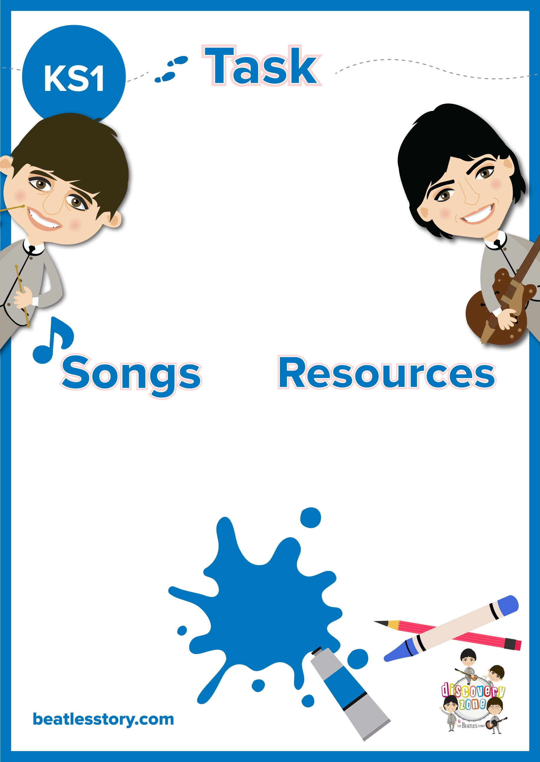

**A Day in the Life Story Writing**

Many of The Beatles’ songs tell a story.

Can you write a short story based on your favourite Beatle song? If you wish you can in include characters from multiple songs.

What adventures do the Fab Four get up to? Do they meet anyone along the way? You may want to create a whole new adventure up for the boys!

CURRICULUM LINKS

English

Music

Pen/ Pencil

Paper

Yellow Submarine

Octopus’ Garden

Penny Lane

Rocky Racoon

Sgt Pepper Lonely Hearts Club Band (Whole album)