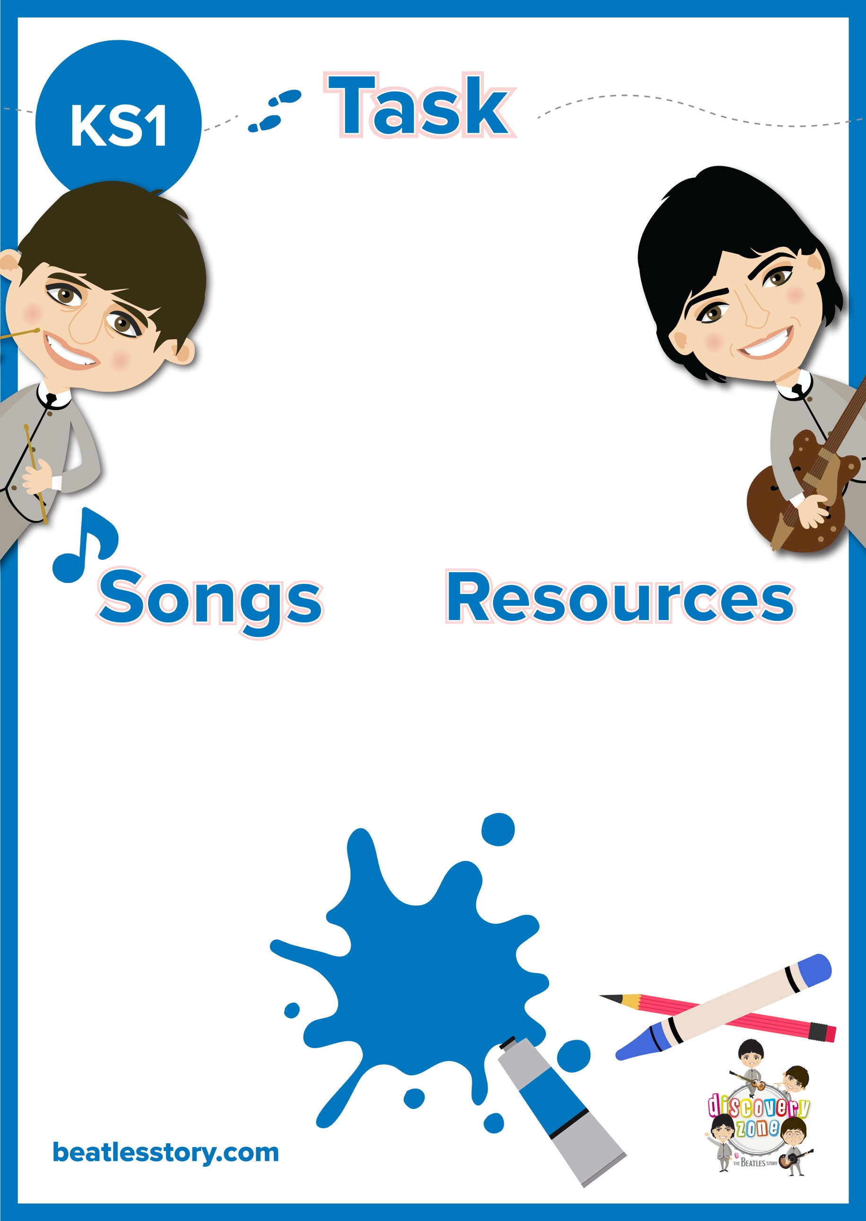

**Biography Writing**

Pick your favourite member of The Beatles (John, Paul, George or Ringo). Research them using any method available to you- books, internet etc.

Can you write a short biography about them? You may want to include: childhood, rise to fame and legacy.

CURRICULUM LINKS

English:

Chronological order, past tense verbs, subheadings

Pen/ Pencil

Paper

John: Lucy in the Sky with Diamonds, Julia, The Ballad of John and Yoko

Paul: Martha My Dear, When I’m 64,

George: Here Comes the Sun, Something

Ringo: Octopus’ Garden, Yellow Submarine