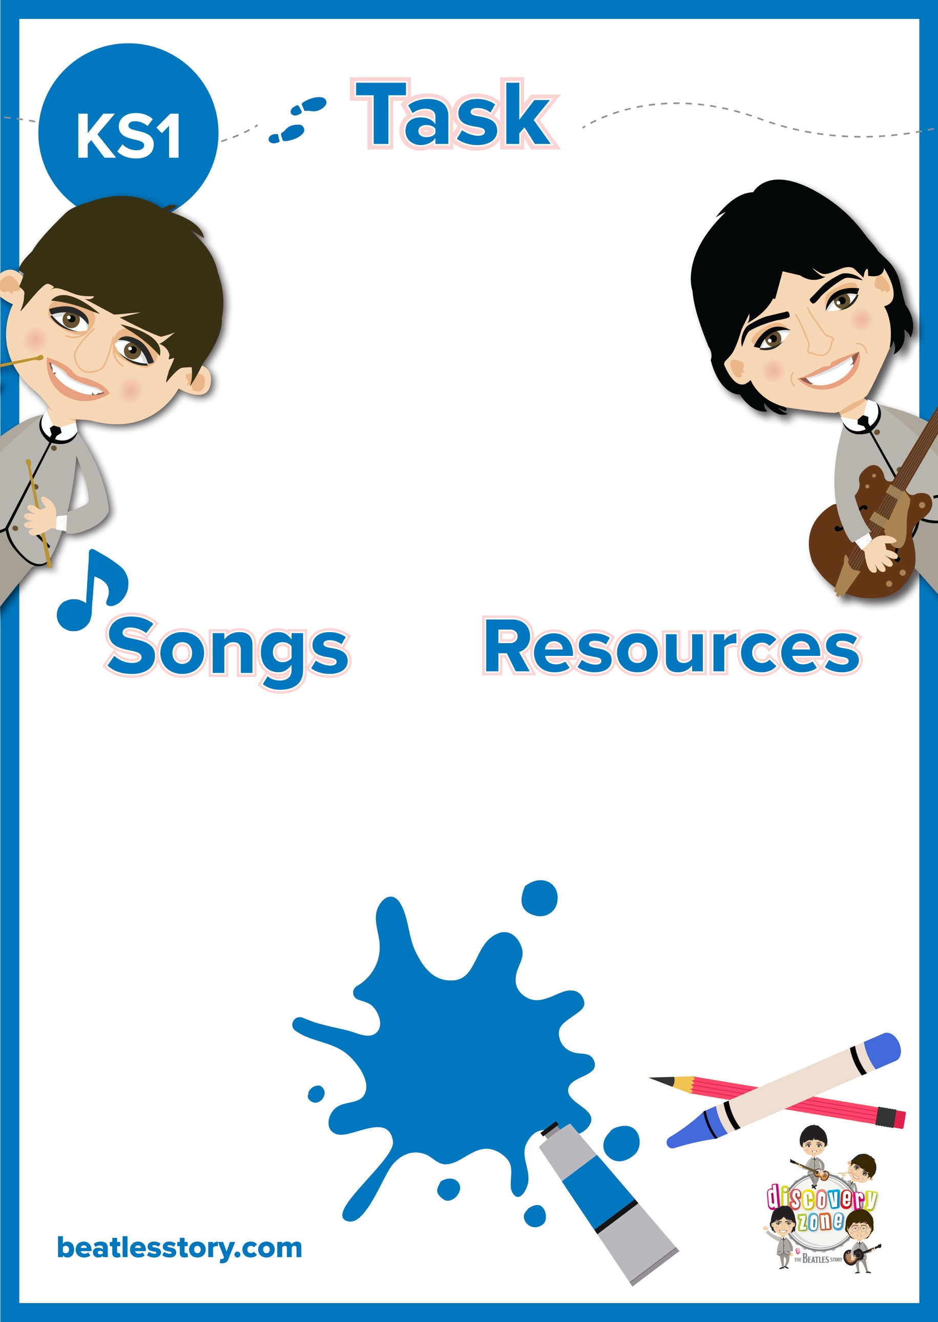

CURRICULUM

LINKS

English:

Simple sentences

adjectives

Pencil/ Pen

Paper

Lucy in the Sky with Diamonds

Eleanor Rigby

Julia

Martha my Dear

Nowhere Man

Doctor Robert

Being for the Benefit of Mr Kite

The Fool on the Hill

Her Majesty

**Character Descriptions**

The Beatles wrote lots of songs about different people and characters. Choose a song and describe the person using simple sentences and adjectives.

For example, ‘Lucy in the Sky with Diamonds’:

Lucy is kind.

She is bright.