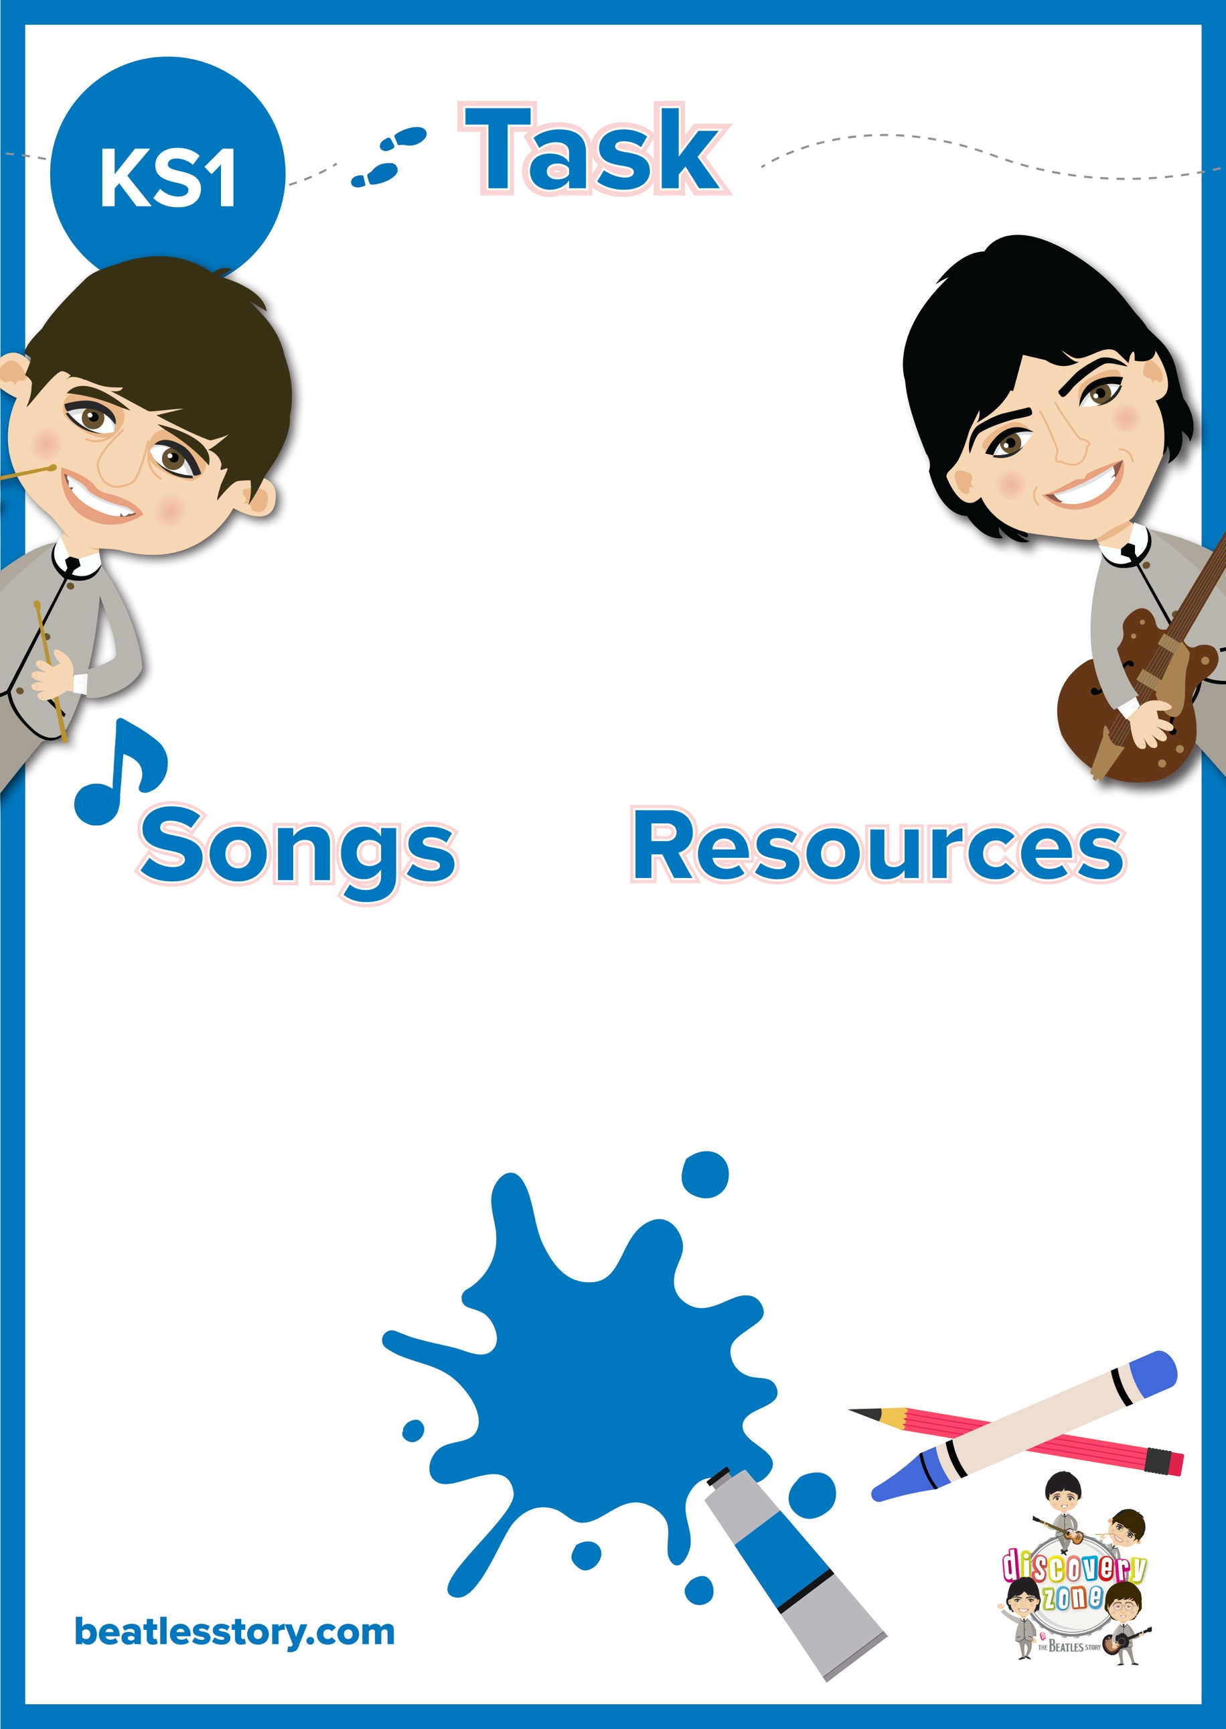

**I read the news today…**

Imagine you’re a reporter for the Merseybeat Newspaper. Set the scene, It’s1964, and Beatlemania has just swept into Britain!

Can you write a newspaper article about The Beatles arriving at a concert?

Include: headline, quotes, the 5 Ws (Who, what, when, where, why)

Pen/ Pencil

Paper

A Hard Day’s Night (album)

Beatles for Sale (album)

CURRICULUM

LINKS

English:

Newspaper writing