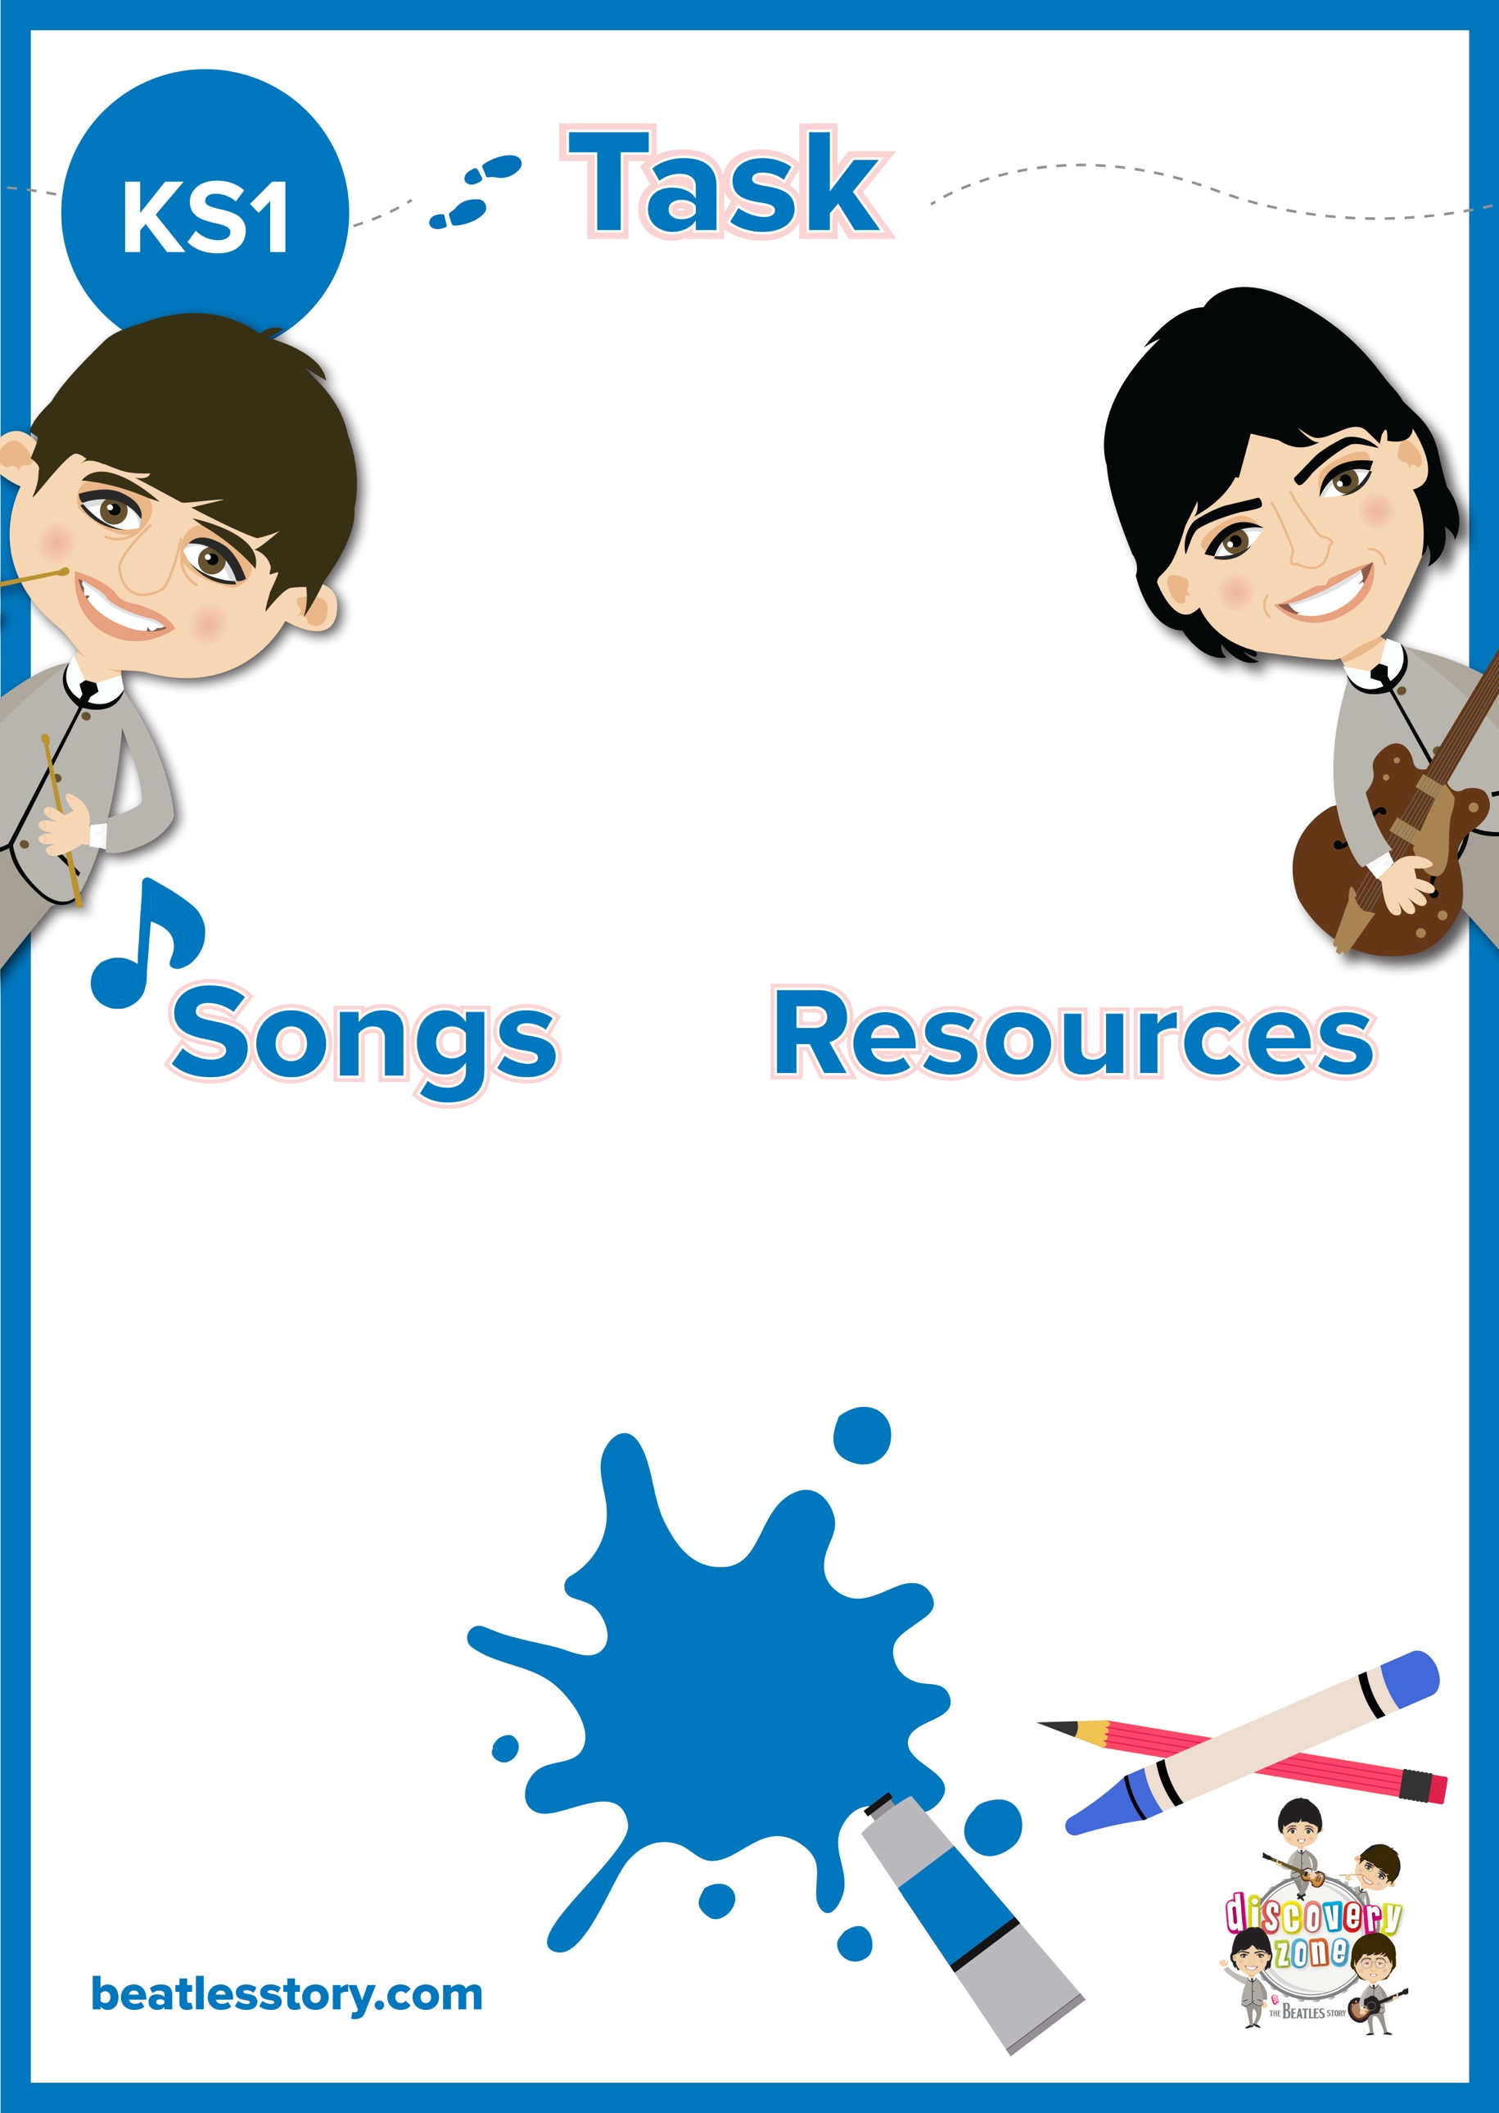

**‘Julia’ Artwork**

‘Julia’ is a beautiful song written by John Lennon about his mother, who sadly passes away when he was young. The song is written in remembrance of the love he had for her.

Have a listen to the lyrics, can you create a piece of artwork based on the imagery in the song?

CURRICULUM LINKS

Art

English

Music

Felt tip pens/ pencils

Paint

Crayons

Paper

Any other media you like

Julia