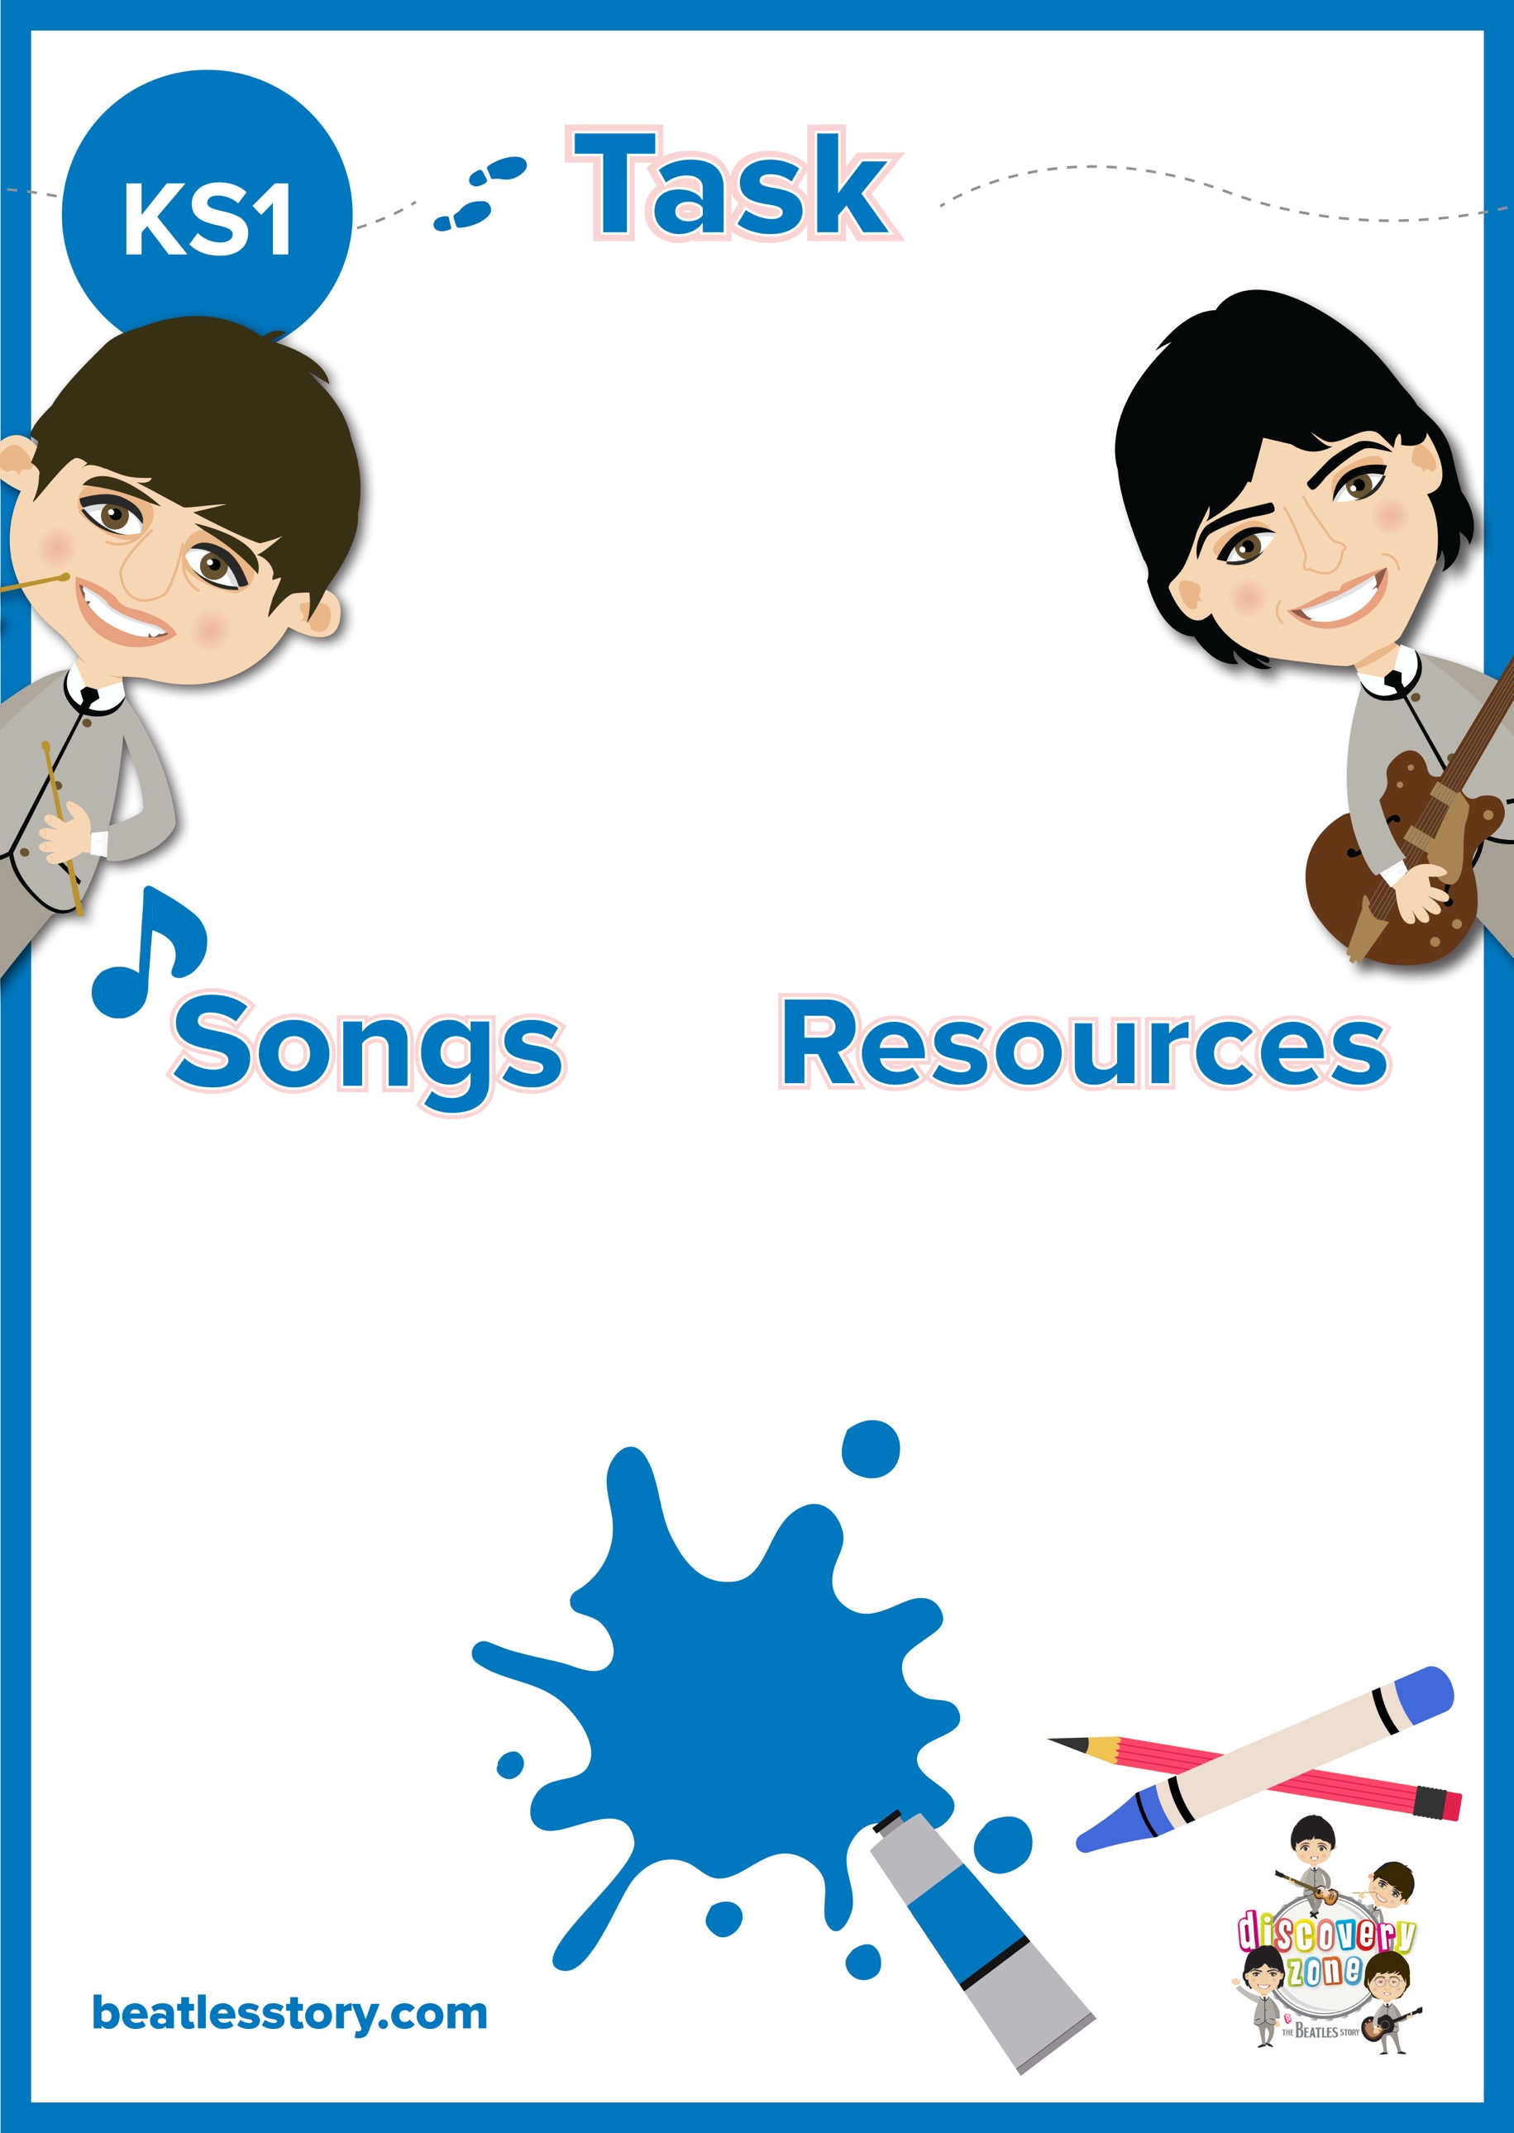

**Persuasive Writing**

‘Are The Beatles the greatest band of all time?’

Can you write a persuasive letter to argue either side?

Do you believe this statement is true?… here at The Beatles Story, we may be slightly biased.

CURRICULUM

LINKS

English:

Emotional language

Rhetorical Questions

Facts/ Statistics

Pen/ Pencil

Paper

We recommend listening to as many Beatles songs as you can to support with your writing (as well as other bands of course to make your research fair)

Some top Beatles hits you may want to listen to are:

From Me to You

She Loves You

I want to Hold your Hand

Can’t buy me Love

A Hard Day’s Night

I Feel Fine

Ticket to Ride

Help!