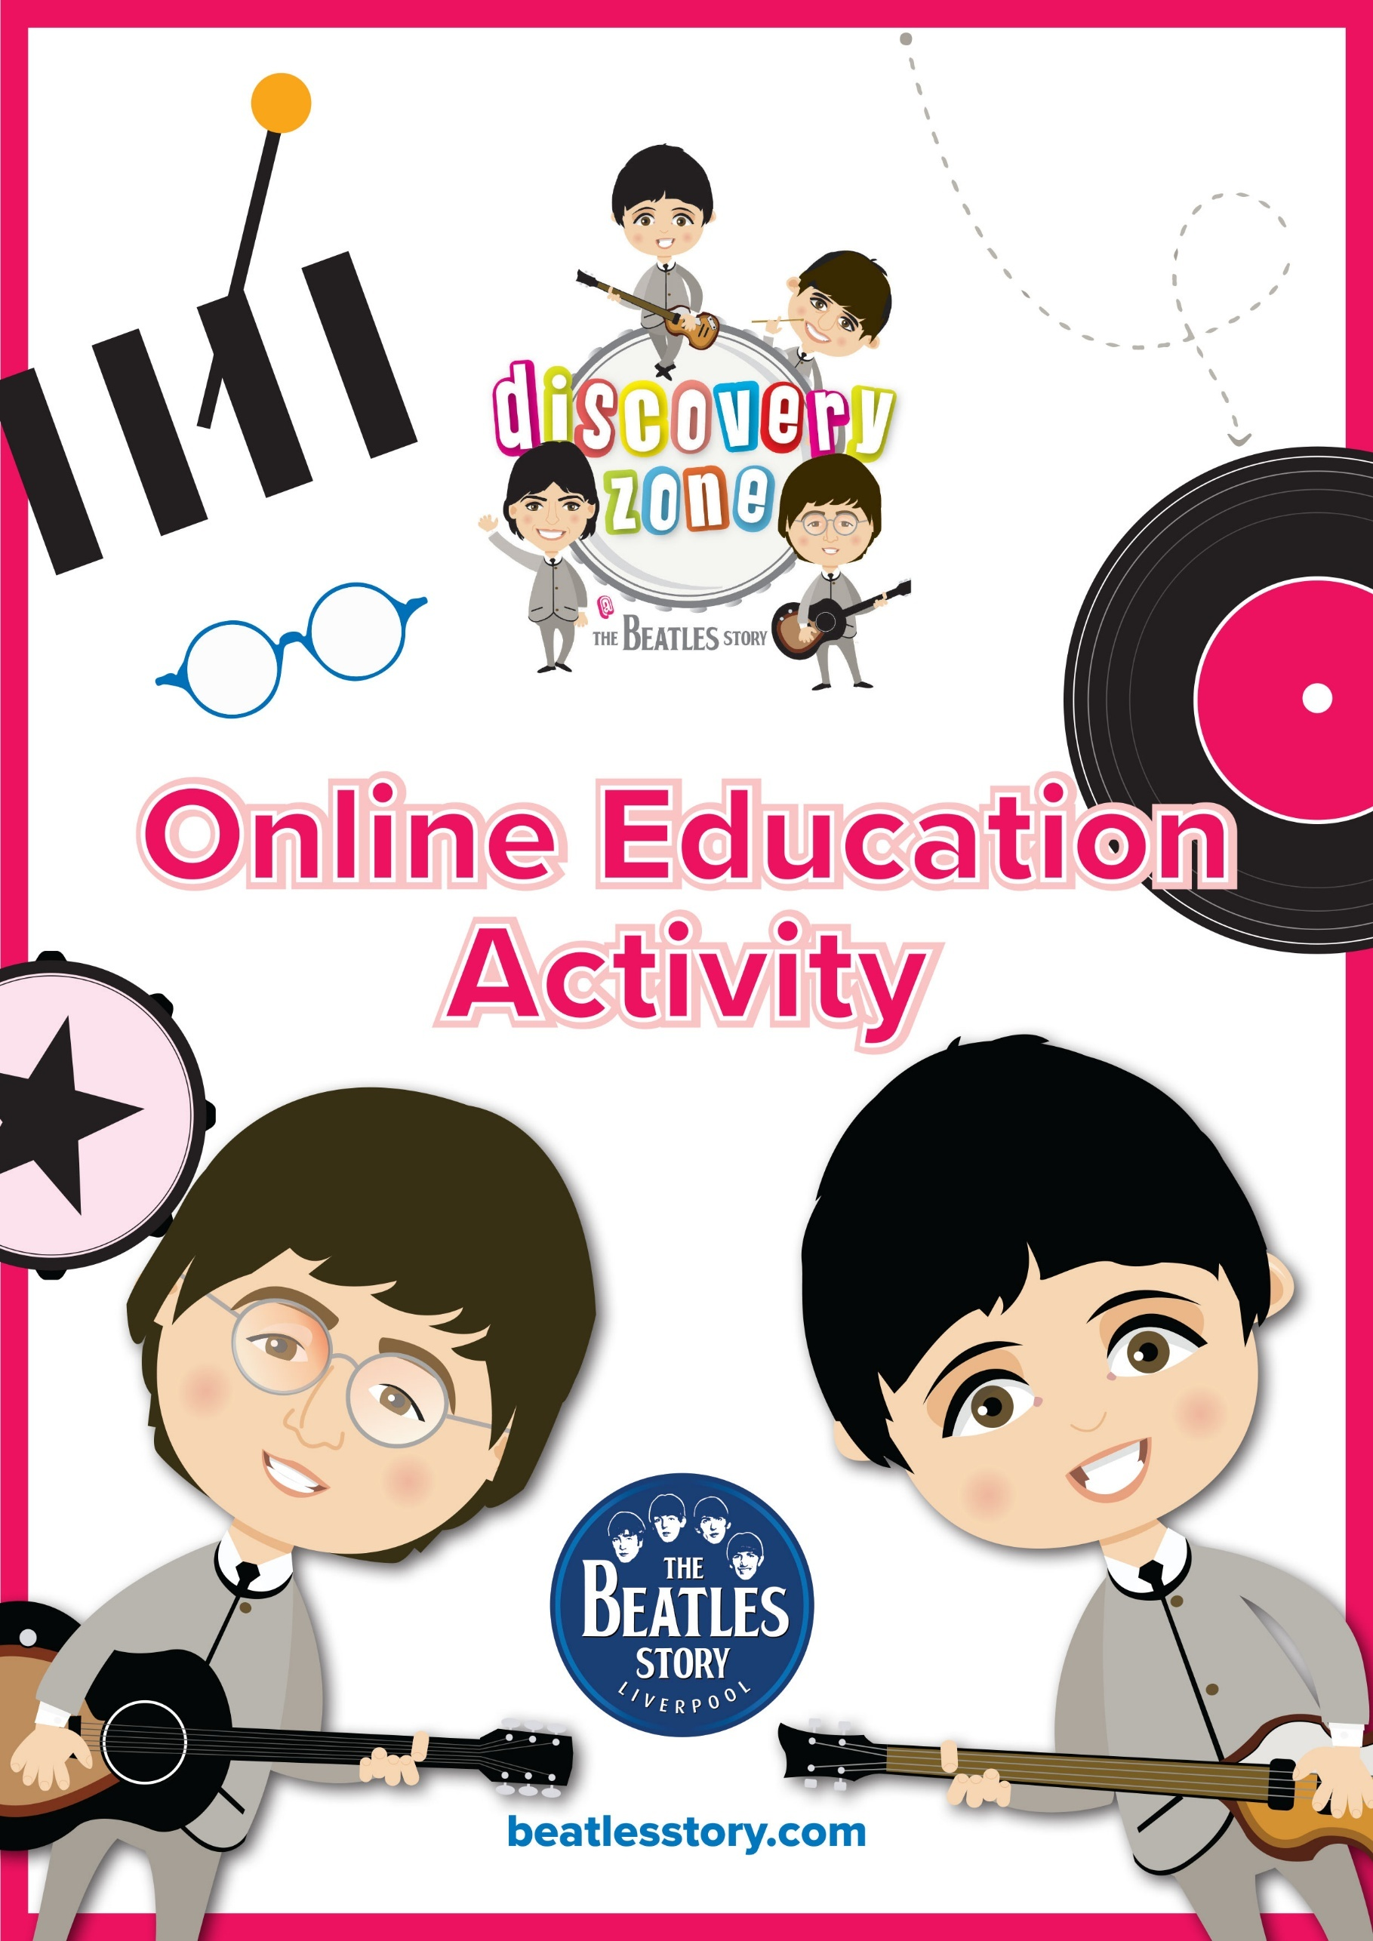
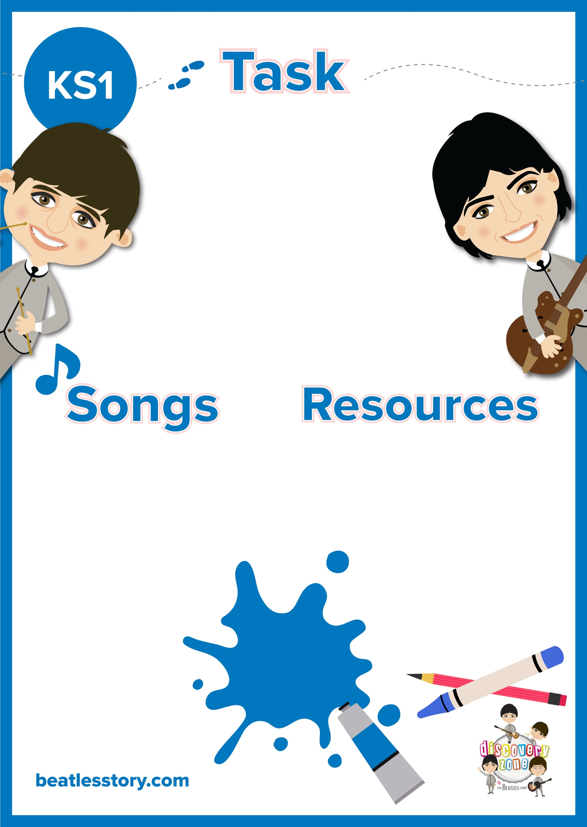

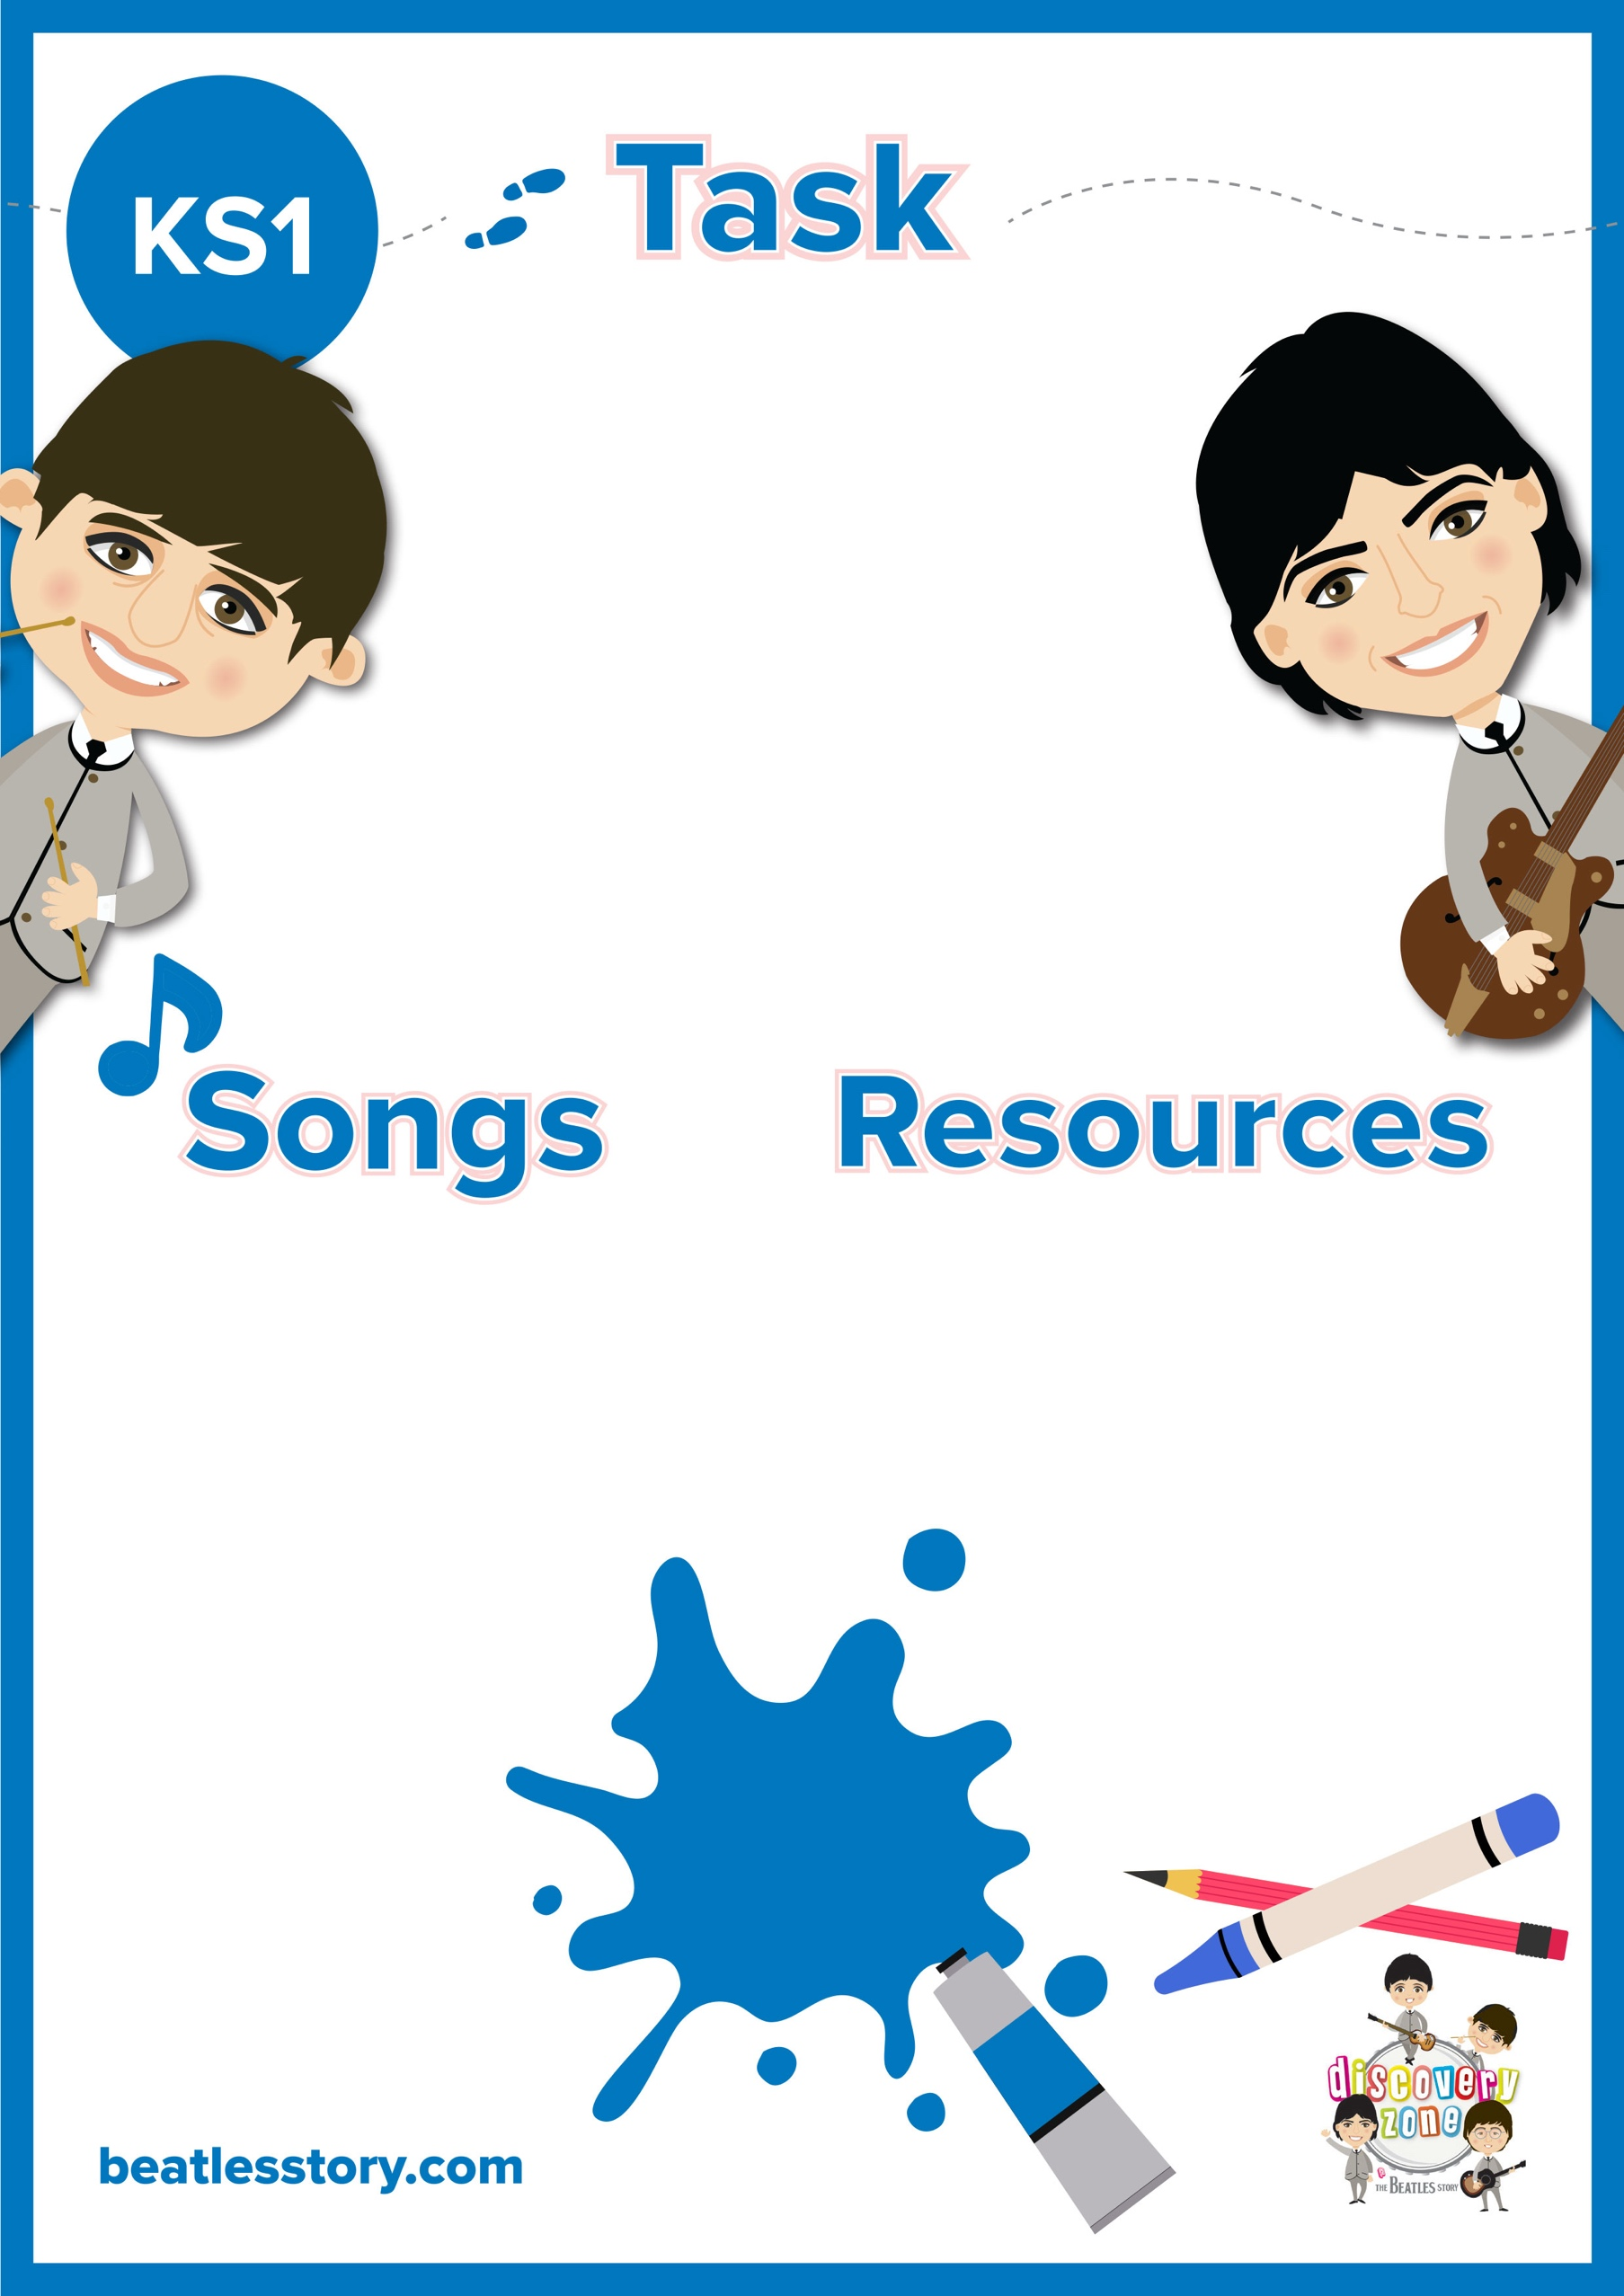
CURRICULUM
LINKS

English:
Simple sentences
Poetry

Pencil/ Pen
Paper

Yellow Submarine
Octopus’ Garden

Rhyme Time
Listen to some of The Beatles songs that include rhyme, such as, ‘Yellow Submarine’ and ‘Octopus’ Garden’.
Can you spot the rhymes?
Now create some of your own rhyming couplets.

