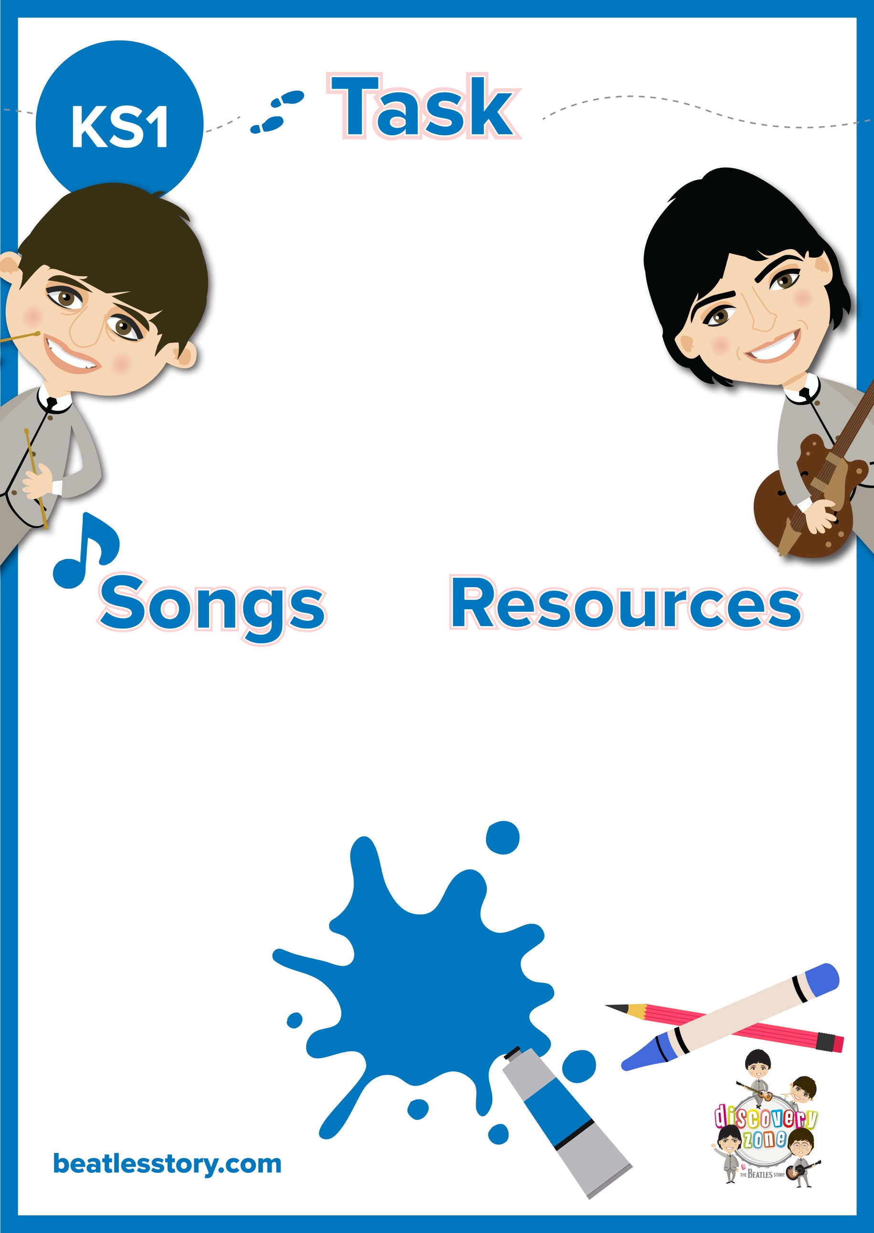

FUN FACT!

The song ‘Yesterday’ came to Paul McCartney in a dream. He woke up and quickly played the song on his piano to make sure he didn’t forget it!

Pens/ Pencils

Paper

Card

Paint

Crayons

She Loves You

All You Need is Love

Love Me Do

P.S I Love You

And I Love Her

Something

From Me to You

Yesterday

**Valentines Day Cards**

The Beatles wrote many songs about love.

Have a listen to a few from the list below and create a Beatles inspired Valentines Day card for someone special, this could be a family member or a close friend.