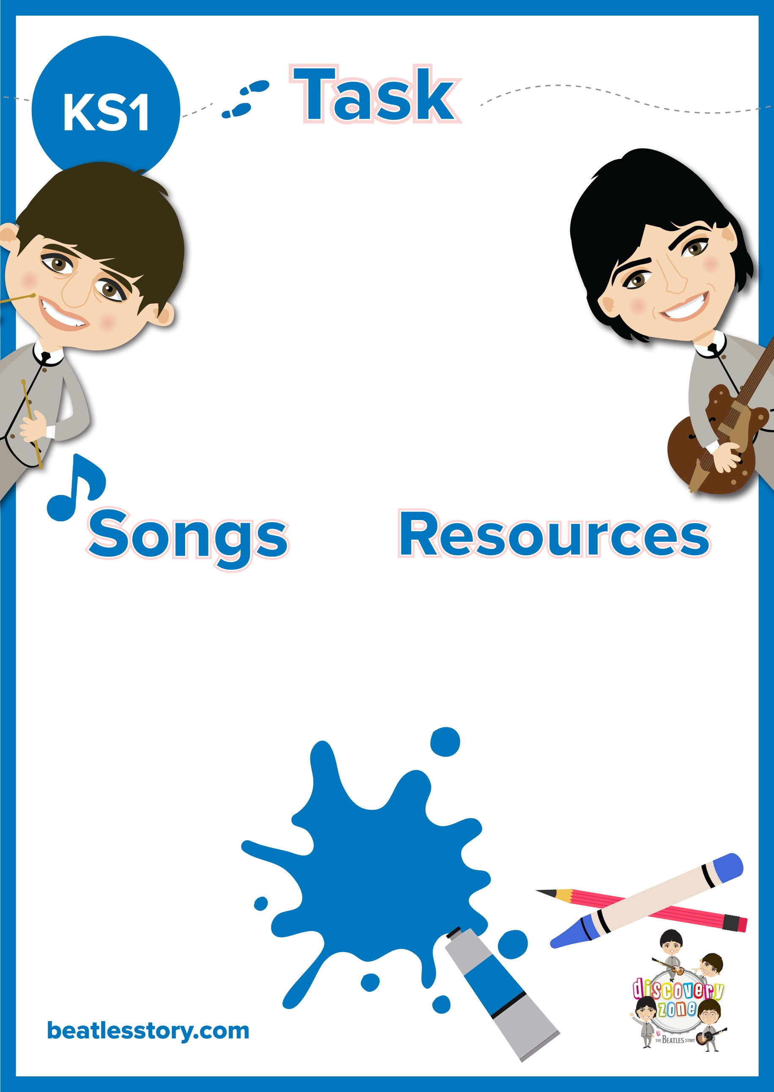

CURRICULUM

LINKS

Geography

English

History

Pencil/ Pen

Paper

Penny Lane

Strawberry Fields

In my Life

Eleanor Rigby

**Where were The Beatles from?**

The Beatles were from Liverpool in the UK. Can you spot Liverpool on a map?

Write some simple facts, e.g. ‘*The Beatles were from Liverpool’*.

The Beatles wrote many songs about different places in Liverpool, have a listen to them.