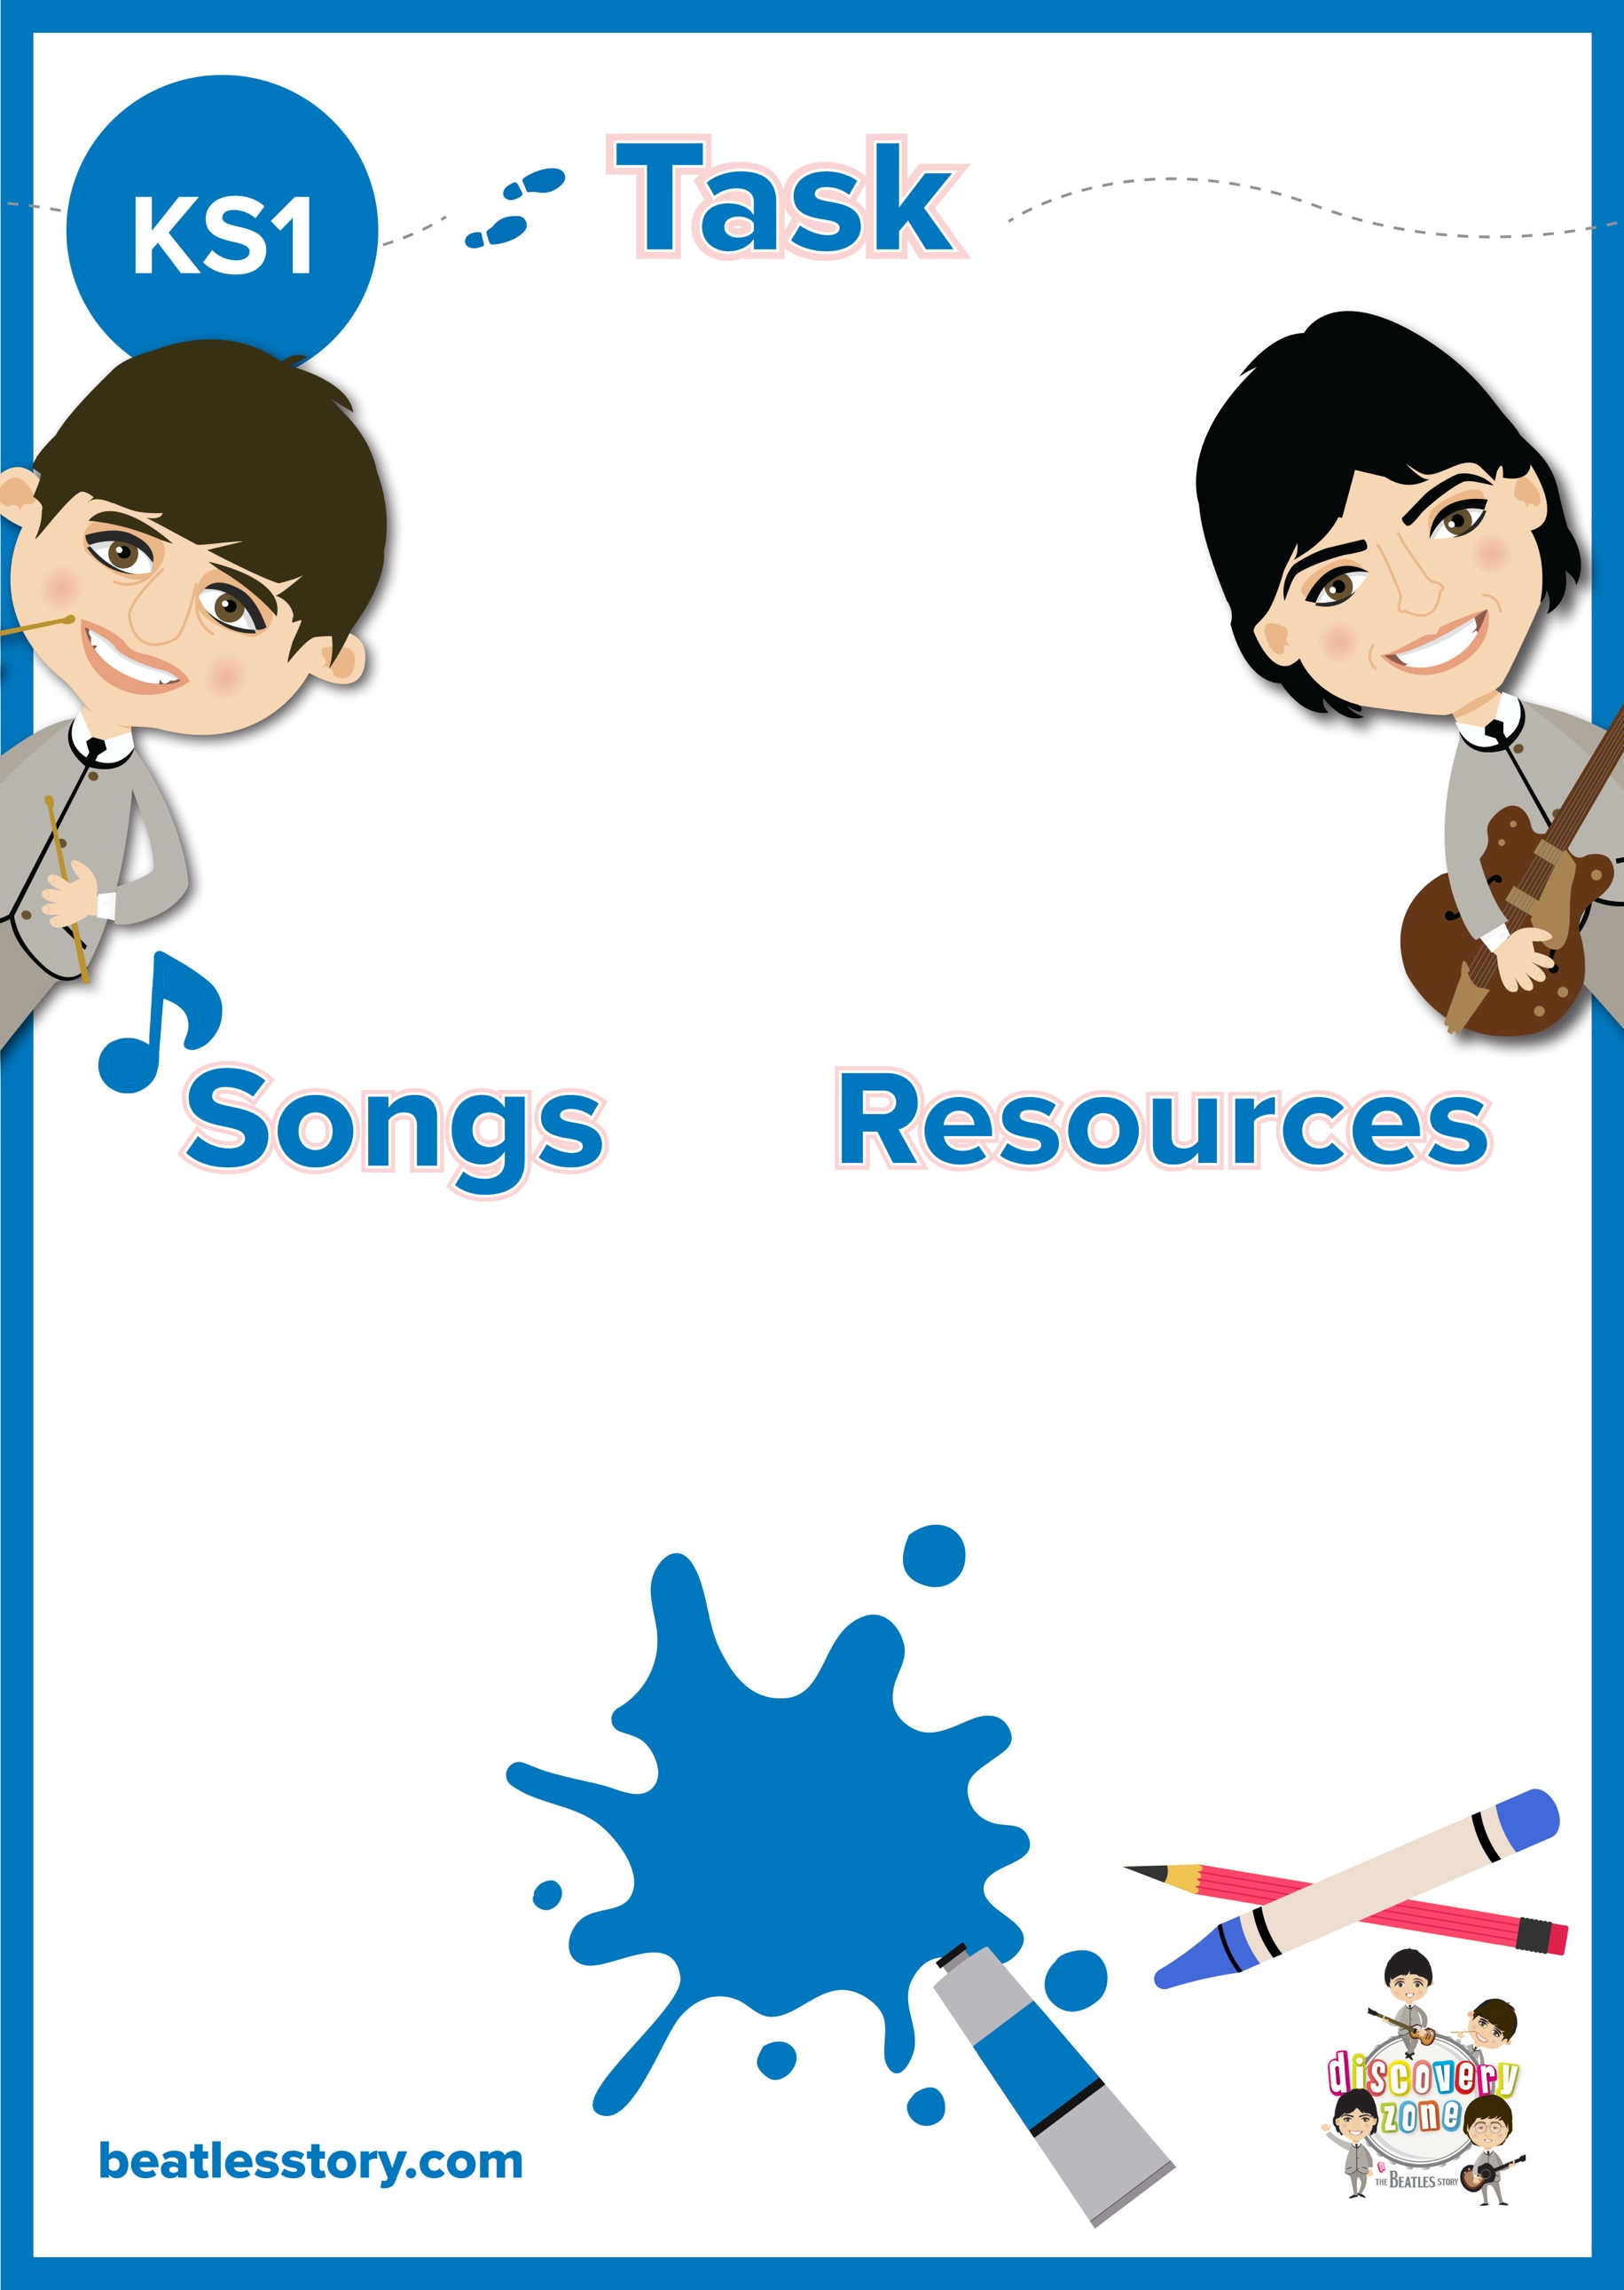

**Write a Love Song**

Many of The Beatles’ songs were inspired by people and loved ones. For example: ‘**Something**’ was inspired by George Harrison’s wife, Pattie Boyd; ‘**The Ballad of John and Yoko’** was inspired by John’s relationship with his wife, Yoko; ‘**Martha My Dear**’ was inspired by Paul’s dog, Martha; ‘**Here there Everywhere**’ was inspired by Paul’s girlfriend at the time, Jane Asher; ‘**Julia**’, written by John Lennon was about his late mother.

Can you write a song or poem about someone who is special to you? Have a listen to some of The Beatles’ songs, they may inspire your writing. The song can be about any type of love- for someone who looks after you and keeps you safe, a pet or anyone who is special to you- maybe a best friend or teacher!

CURRICULUM LINKS

English

Music

Pen/ Pencil

Paper

Something

The Ballad of John and Yoko

Martha My Dear

Here There and Everywhere

Julia