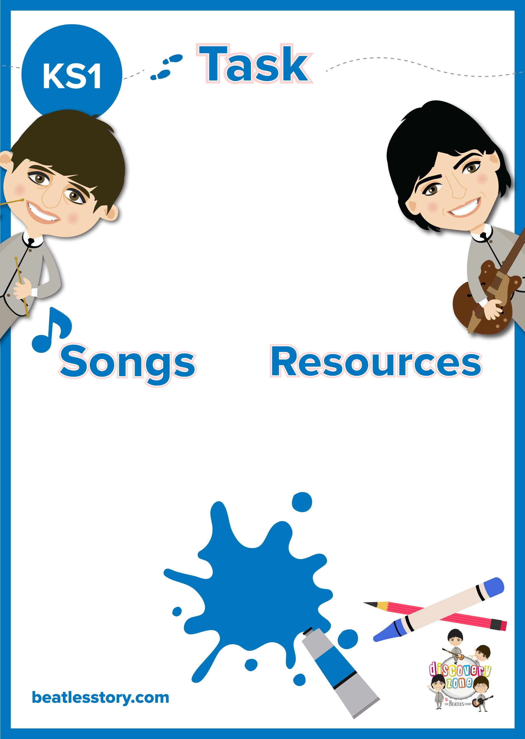

CURRICULUM

LINKS

Art

English:

Simple sentences

adjectives

Pencil/ Pen

Paper

Yellow Submarine

**Yellow Submarine**

Listen to The Beatles song ‘Yellow Submarine’.

Draw a picture of what you imagine the Yellow Submarine to look like.

Can you write sentences to describe your submarine? For example, *‘My Submarine is big and red.’*