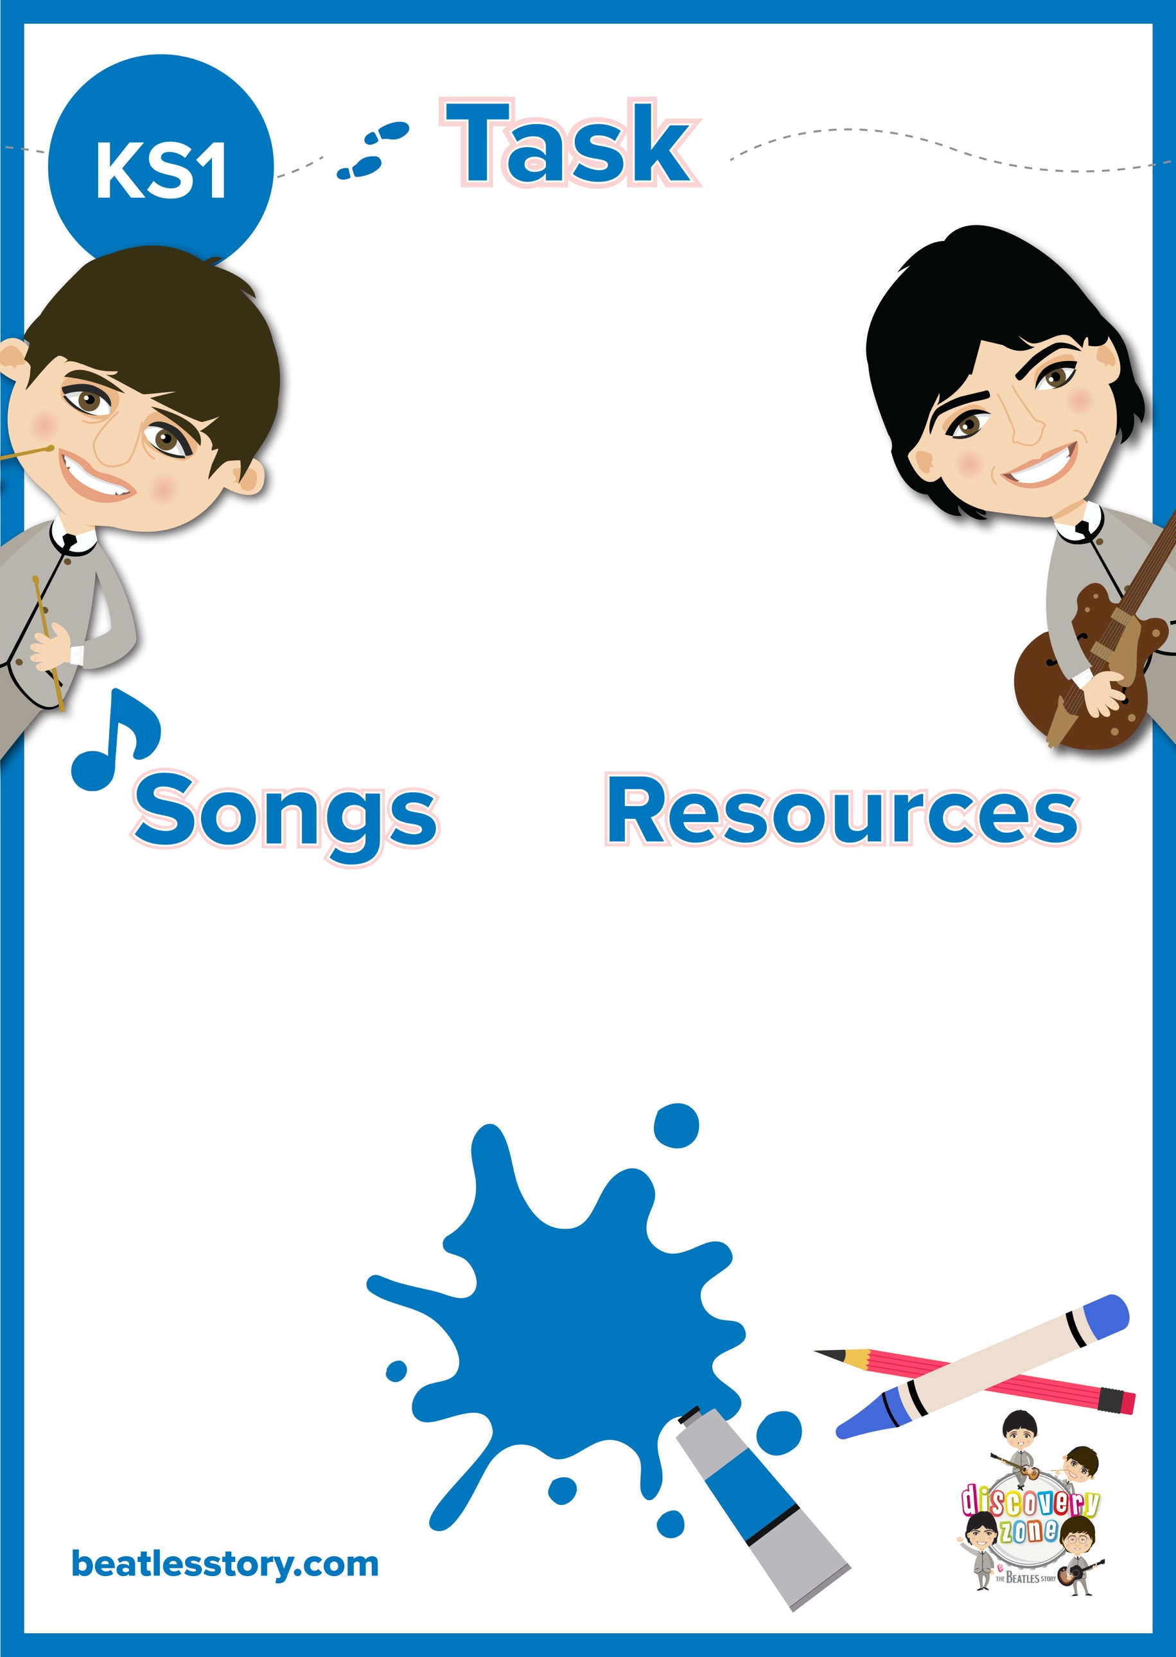

**You Know My Name**

The Beatles are famous for writing songs based on particular characters. The characters are sometimes fictional, for example, ‘Billy Shears’ from the ‘Sgt. Pepper’s Lonely Hearts Club Band’ album. Others are based on real people, for example, ‘Lucy in the Sky with Diamonds’ was written by John Lennon, when his son, Julian, brought home a picture from school inspired by his friend, Lucy.

Can you choose a fictional character from a Beatles song and draw what you think they might look like?

CURRICULUM LINKS

English

Art

Music

Felt Tip Pens

Pencils

Paper

The Fool on the Hill

Mean Mr Mustard

Rocky Racoon

With a Little Help from My Friends (Billy Shears)

‘Lucy in the Sky with Diamonds’